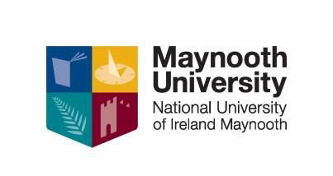
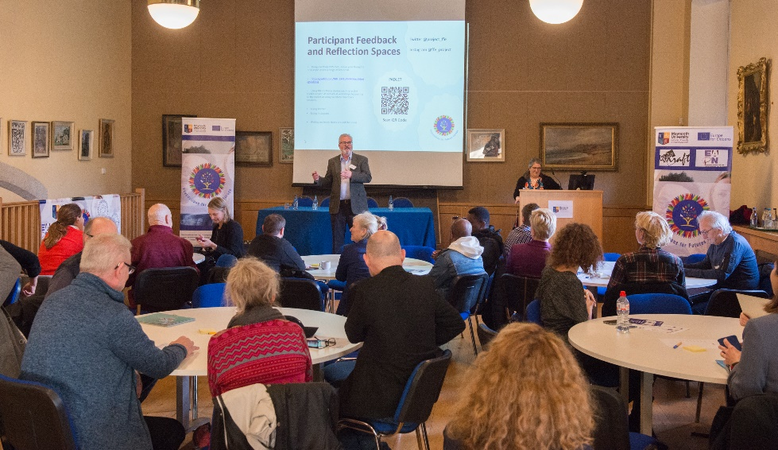

NUI CERTIFCATE IN ADULT AND COMMUNITY EDUCATION

Level 8 (20 ECTS)

OVERVIEW
Adult education is a transformative and powerful tool for change. Impacting positively on the lives of those who participate, their wider communities and society as a whole, adult education provides a platform for radical and progressive thinking. The Certificate in Adult and Community Education, delivered by experienced and dedicated tutors, introduces research based teaching and learning methods which will provide students with both the knowledge and practical skills required to work with adults across a range of settings. The course provides an excellent foundation for those considering a change in career towards adult teaching or for people employed in sectors where communication with adults in a learning environment is required such as libraries, galleries, museums, etc., or educational settings for rehabilitation and recovery.

WHO IS THIS QUALIFICATION FOR?
People working OR wanting a career in Adult and Community Education, Further Education, Training and Development. People seeking to expand and enhance their knowledge in the
areas of Group Skills, Facilitation, Presentation skills. People working in Training and Development and seeking to develop their practice and gain a deeper understanding of the philosophy of education and the psychology of adult development. Key Workers, Librarians, Teachers, Volunteers, Managers, Service Providers etc., who are involved in communicating with adult learners.

COURSE STRUCTURE:
The duration of the course is 100 hours. Students will attend 1 evening per week for a 3 hour facilitated workshop/tutorial. Students will also attend 3/4 Saturdays over the duration of the course. Modules include: Psychology of Adult and Community Education; Philosophy of Adult and Community Education; Groupwork and Facilitation Skills. Adult Learning in Groups; Foundational and Emerging Theories in Adult Learning; Power and Inequality in Education; Understanding How Learning Happens.

DATES, VENUES AND FEES
This course will commence October 2024 on campus in Maynooth University (the course can be delivered on site for individual companies once the minimum number of 16 participants register)

Fee: €1400. An Easy Payment Plan is available upon registration. (A reduced Company Rate will apply for a student cohort of more than 6)

Part time students may be eligible to for the Student Assistance Fund (SAF) to help with the associated costs of attending a university course such as Travel, Childcare, Utilities, Materials etc. Once registered to this course you should first consult: SAF Guidelines to see if you qualify and then e-mail student.budget@mu.ie to make further enquiries.

CPD & PROGRESSION
Students who complete the Cert. in Adult and Community Education successfully and who hold a primary degree may request to have this certificate taken into account by the HDFE Course Directors for Recognition of Prior Accredited Learning should they be successful in application to that Post-graduate programme. The NUI Certificate in Adult and Community Education is a standalone qualification however, when combined with the NUI Certificate in Equality Studies (On Line) and another of our certificate courses such as Disability Studies or Addiction Studies it forms part of the Diploma in Arts: Training and Development for Socially Inclusive-Workplaces.

CONTACT US
Apply HERE: contact Kay on 01 708 6062 kay.loughlin@mu.ie

