

Department of Anthropology PhD Information
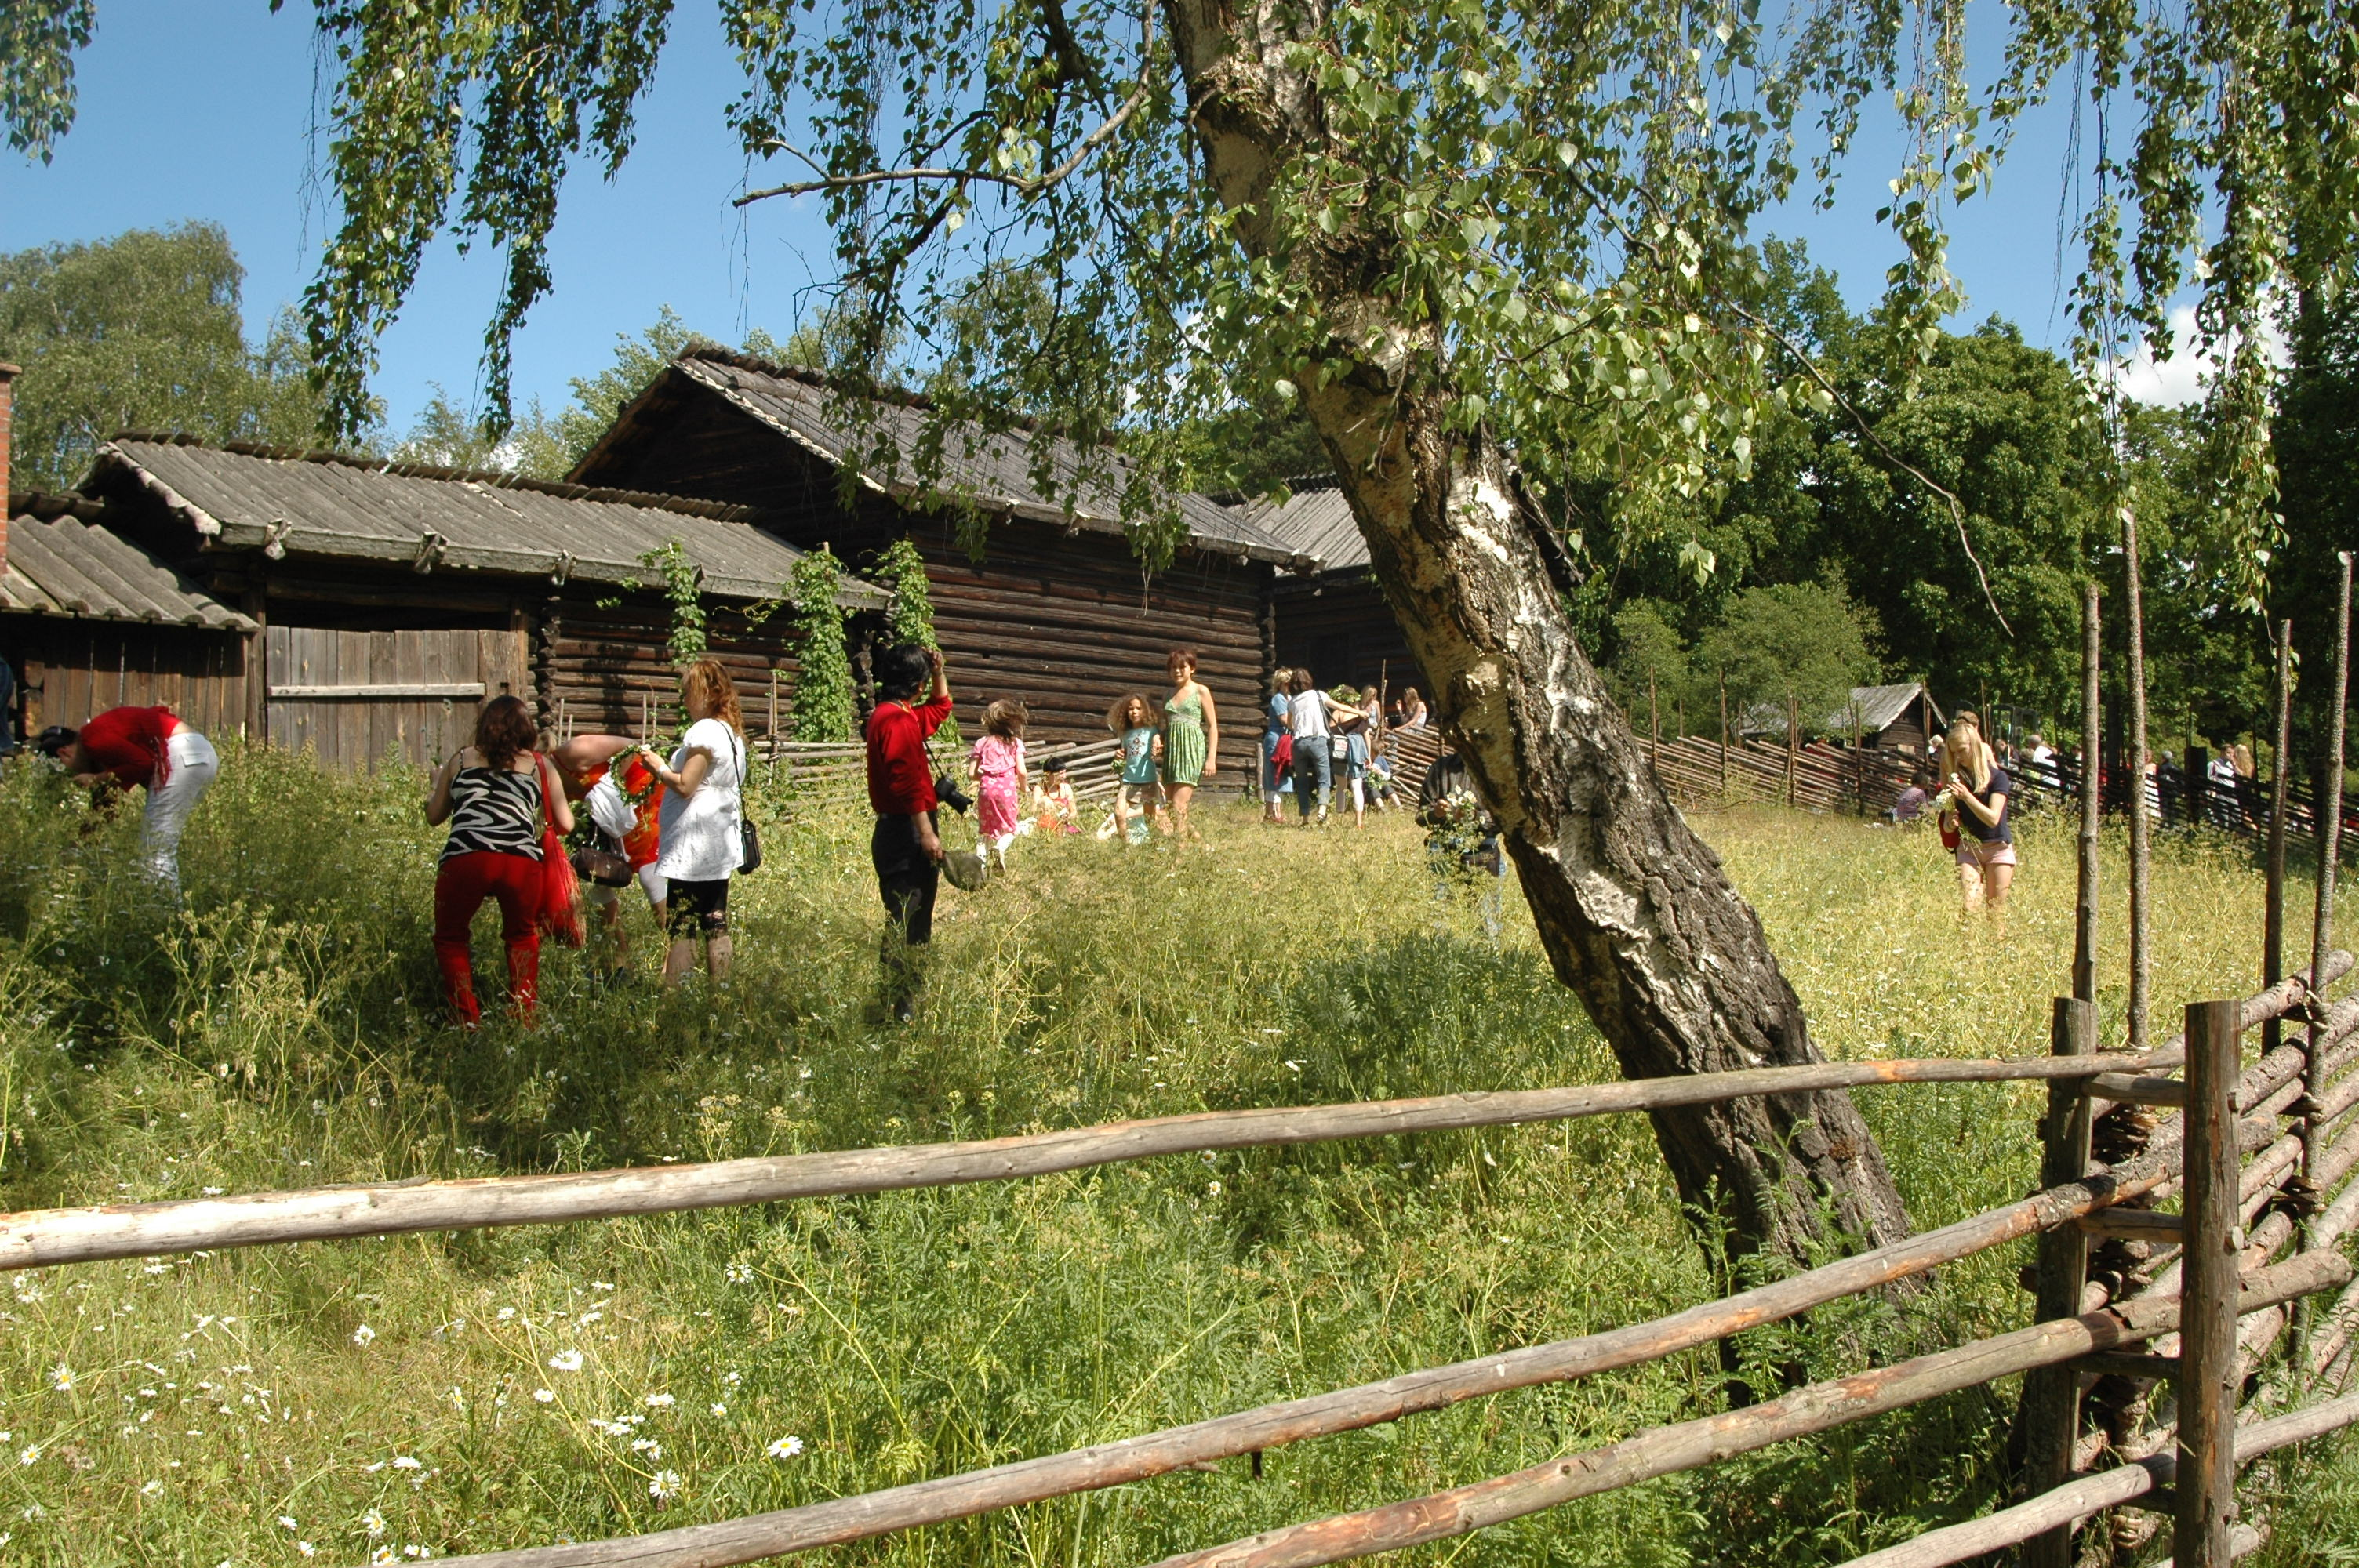
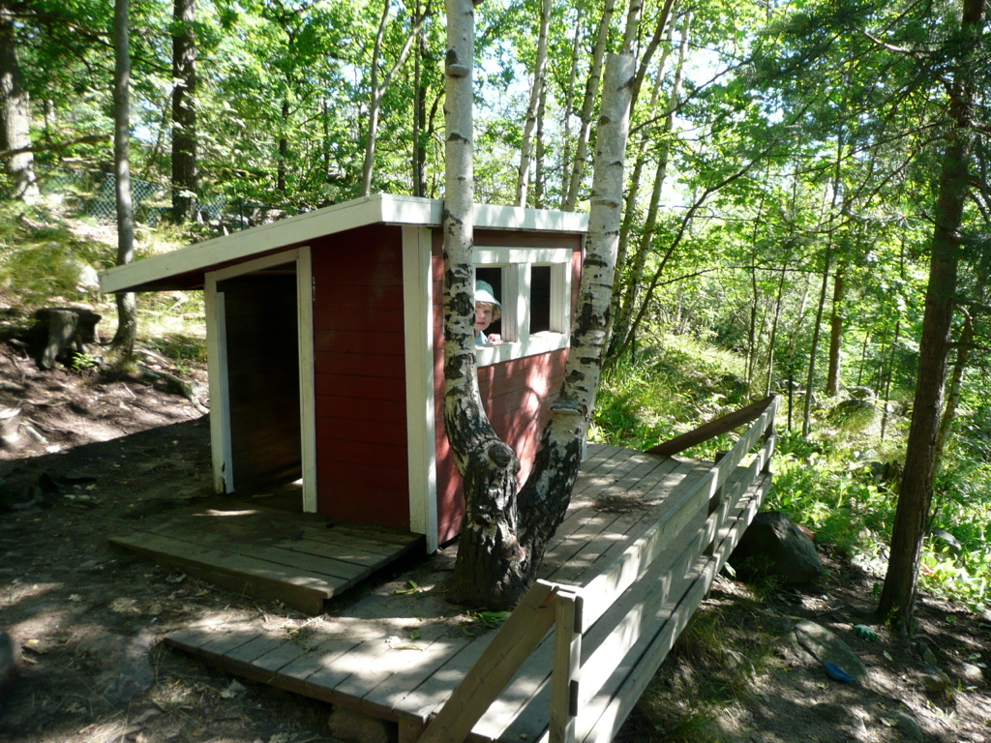
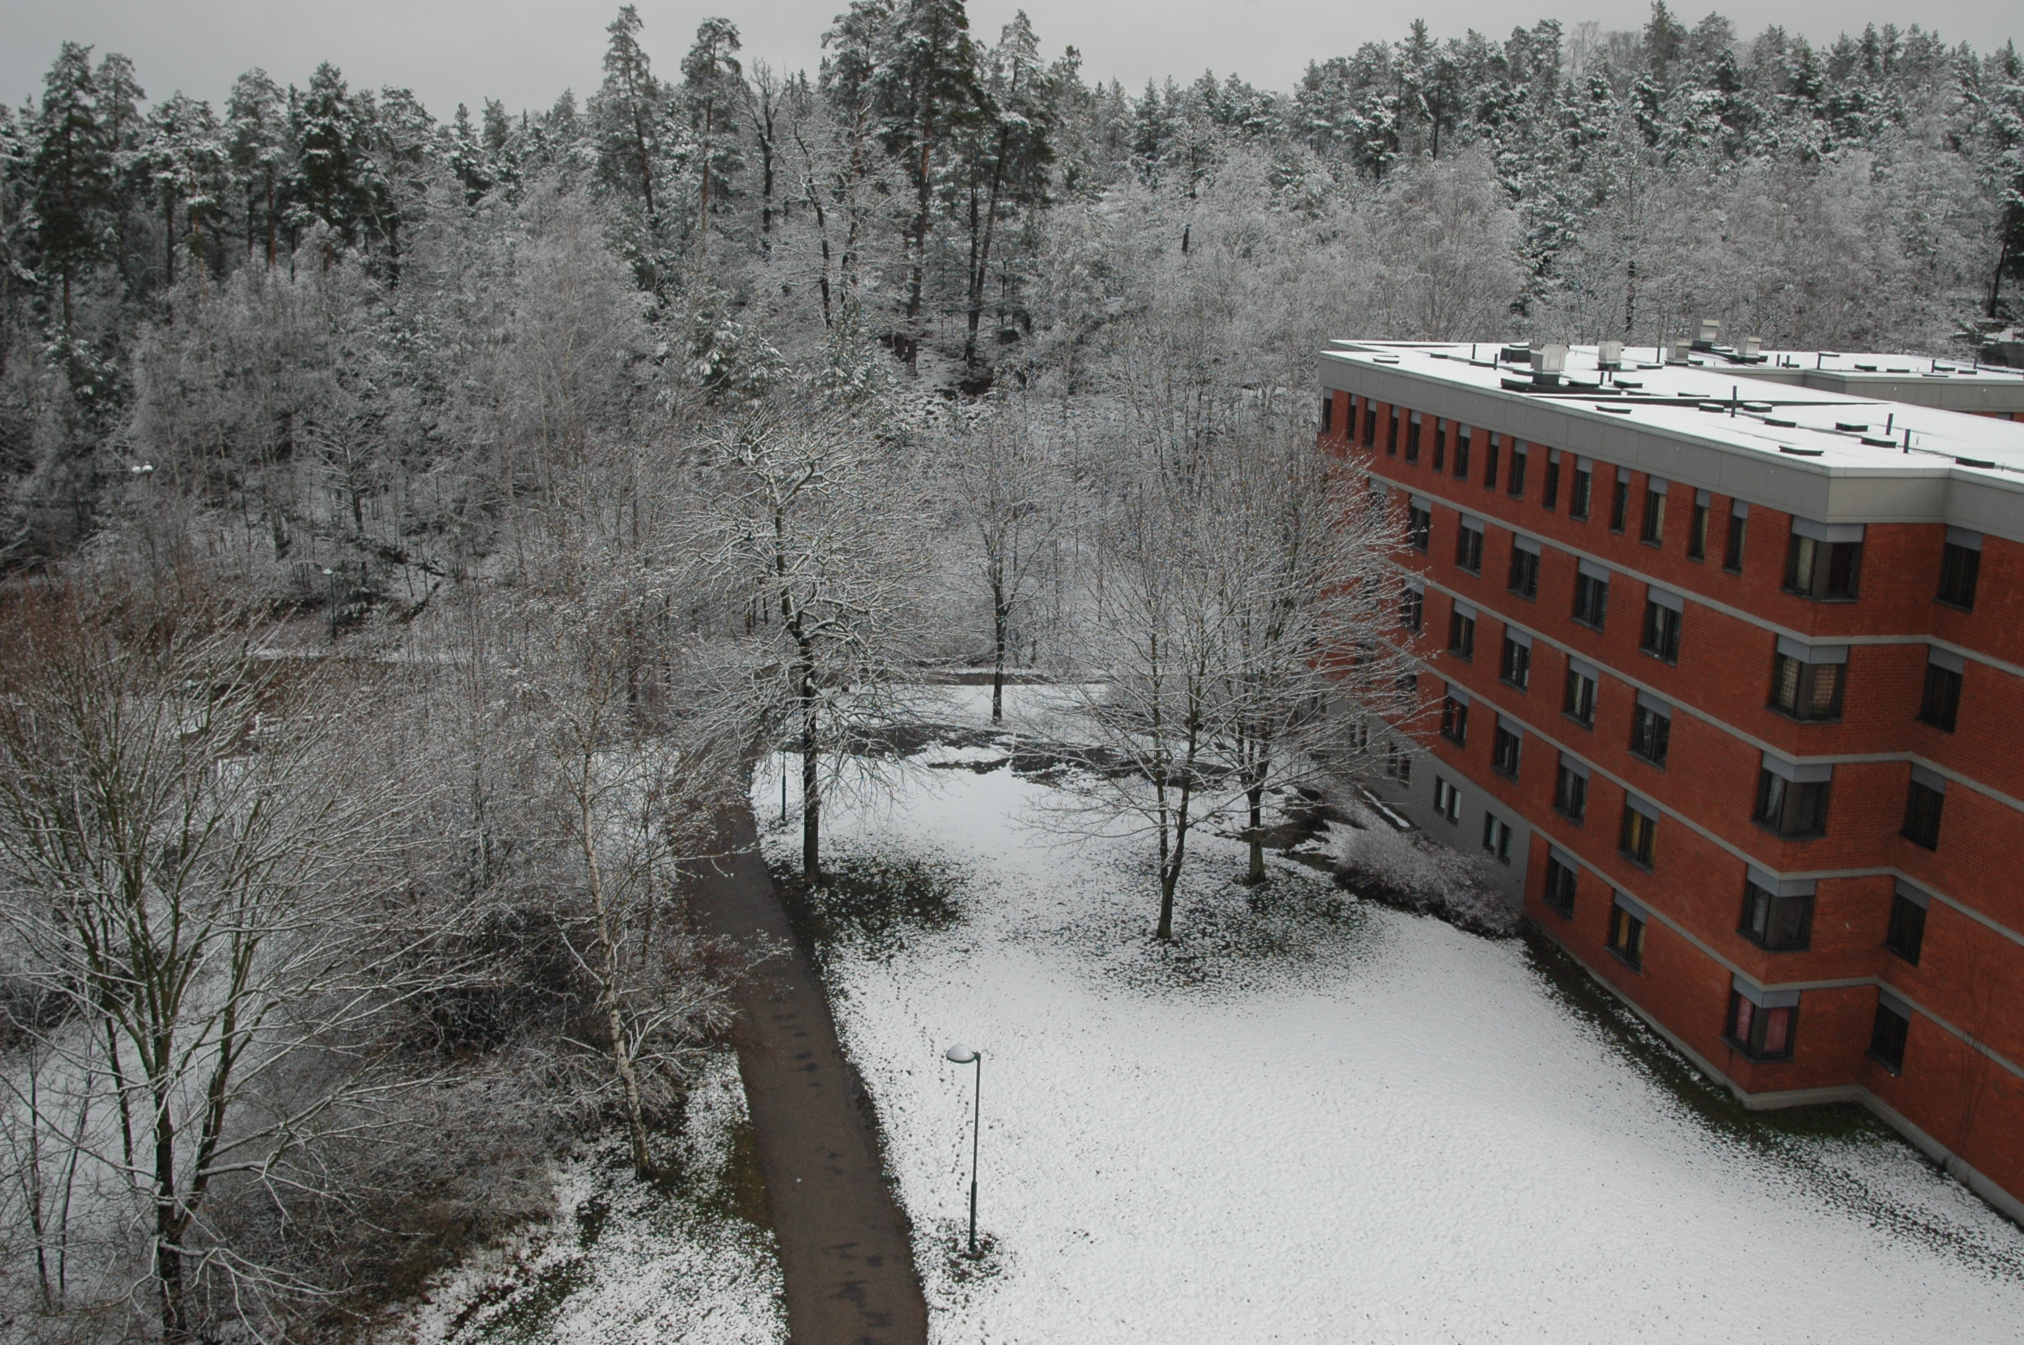

Welcome to the Department of Anthropology!

Below is some information that you might find helpful as you progress through your PhD. This document is meant to complement the Graduate Student Handbook that is produced by the Graduate Studies Office, which you’ll find here:
https://mu.foleon.com/maynooth-university/postgraduate-prospectus-2022/taught-programmes-listing/

Here, you will find some excerpts from the Handbook, but also some information that is specific to the Anthropology Department.

Although we make every effort to update this information annually, it is always subject to revision and may alter from year to year.

If you have any queries, do please contact your supervisor or the Departmental Director of Postgraduate Studies (ajamie.saris@mu.ie)

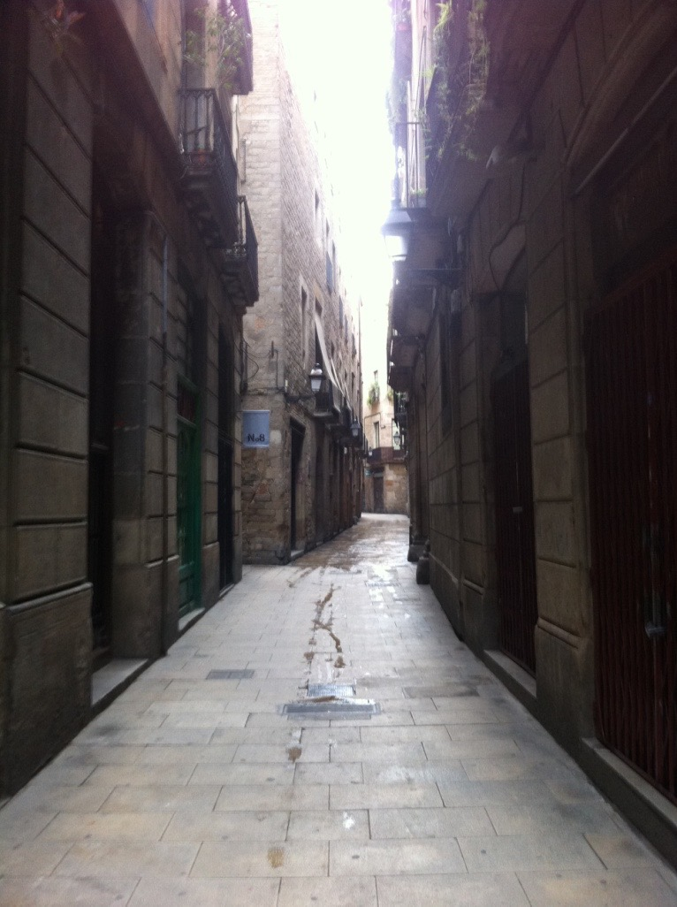
Orientation:
When you arrive in the Department of Anthropology, one of the first things you should do is attend the Postgraduate Orientation. This takes place in September each year. You’ll receive an email beforehand with details of when and where! At this meeting you will have an opportunity to meet faculty and other members of the postgraduate community in anthropology. We’ll also talk about departmental facilities and answer any questions you might have.

Initial Meeting Record
Soon after registration, you should hold the initial meeting with your supervisor(s). The purpose of the initial meeting is to identify modules that will enhance your research, and to agree to a calendar of meetings. This is an opportunity for you to discuss your options within the structured PhD programme and familiarise yourself with departmental and university offerings and requirements (see the Graduate Student Handbook for details)

You and your supervisor should agree on your academic programme and record it in the initial meeting record (IMR). Then your supervisor submits it to the anthropology office to be approved by the departmental research student progress committee (DRSPC). Finally, the IMR should be forwarded by the DRSPC to the Graduate Studies Office (GSO) by the end of October.

Credits within the structured PhD programme (from the Graduate Student Handbook):
Maynooth PhDs work within a structured PhD programme. In the following section you’ll find some information regarding how this works from the Graduate Student Handbook. Please consult this handbook and speak to your supervisor when deciding which modules are right for you.

Students who have a four-year undergraduate degree or a three-year undergraduate degree plus a masters are required to earn at least 30 credits. Subject-specific modules must make up 15 credits and transferable modules must make up 15 credits.

Students entering the Faculty of Social Science, who have completed a three-year undergraduate programme, are required to earn a minimum of 60 credits, with at least 15 credits in subject specific modules and 15 credits in transferable modules, up to a maximum of 90 credits.

3.1. Subject-specific modules
Subject-specific modules involve advanced specialist doctoral level courses provided by a department/research institute. Subject specific modules also include master’s level taught modules in the discipline area or in a cognate discipline area. Students must take a minimum of 15 credits in subject-specific modules.

3.2. Transferable skills modules
Transferable modules include modules offered in disciplines other than primary research areas that would enhance the student’s skills development. These modules are designed to assist the student to develop and manage their research and future careers across a broad range of employment sectors, including academia.
Students must take a minimum of 15 credits in transferable modules.

If a transferrable skills module is not part of the departmental programme, students wishing to register for the module must have the support of their supervisor(s). Students must complete the Form for registering for transferable modules and forward it to Registry (Student Records Office).

3.3 Inter-University and external modules
A range of inter-university modules and external modules are available for research students. These are usually subject specific modules. Details of the specific registration process should be sought from the module/programme coordinator, where the particular module is being taught.
In the case of the student undertaking an external module as part of their departmental structured programme: when the module is completed, the student should bring the transcript to their Maynooth University module/programme co-ordinator for processing.

In the case where the module is not listed as part of the departmental structured programme, the student must seek the approval of the supervisor(s) before attending such a module. After completing a module, the student should complete the Gain Accreditation for Inter-Institutional Modules form and forward it together with the results to Registry (Student Records Office) for processing.

Required modules within the Anthropology Department: AN801
All first year PhD students in our department are required to take AN801 Theory and Practice for Anthropologists, which consists of reading and discussing an ethnography with members of staff. There are two meetings each semester. Scheduling is flexible and usually the faculty member and student agree on a date and time that suits them to meet.

Anthropology Department Seminar Series
Please keep an eye out for department seminars to which we invite staff and students. Some of these sessions are limited to MA students only, but for those that are open to all staff and students we strongly recommend that you attend those as student members of our anthropological community.

Ethical Review
Before embarking on research you must have submitted and been approved for ethical review. When filling this form it is important that you work closely with your supervisor.

You’ll find details of the university stance on research ethics here: https://www.maynoothuniversity.ie/research/research-development-office/research-ethics



Assessment: The Annual Review
The Anthropology Department will undertake formal annual progress reviews of all PhD students at the end of each year.

1st Year Annual Progress Review

The first-year annual progress review (which takes place approximately nine months after initial registration) allows the Department Research Student Progress Committee to monitor the student’s initial progress and provides a mechanism for identifying and resolving problems early in the process.

Steps you need to follow in preparation for assessment in Year 1:

1. Agree on content:
In consultation with your supervisor/s, you should agree a broad outline of the shape of this piece of work and both sign off on it.

The assessment in Year 1 consists of a written requirement, which is tailored to each student’s stage of research. Ideally, this document should be an extended or amended proposal with discussion of relevant anthropological literature, but other possibilities are available too, such as an annotated bibliography or a couple of extended essays that discuss a topic that lies at the heart of your research interests. Altogether, the piece of work should be substantial (generally between 5000-7000 words) and provide evidence of the progress you have made during Year 1. The DRSPC will work closely with your supervisor to gauge how ‘progress’ is measured.

If you and your supervisor agree that an updated or extended research proposal is appropriate, do not expect that it must deliver answers or a fully-formed argument. Instead, it should outline the space of possibility that you wish to explore, demonstrating your relative familiarity with the literature of the field you are working in and considering issues other anthropologists have raised. A thorough research proposal might identify a phenomenon or field site, and also specify an argument, concept, or set of anthropological interpretations that you wish to examine. As well as the ‘why’ questions, you should also consider the ‘how’ questions: where will you do fieldwork, how will you gain entry, do you need any skills such as learning a language before you start, are you proposing to embark on 12-16 months fieldwork, or is an alternative plan more appropriate to your research project?

2. Develop a full draft of the r 1 Report:
This piece of work which will form the basis of the 1st-year PhD seminar should be submitted electronically to the Anthropology office by late April.

3. Present your work to the department as part of the seminar series:
In early May of Year 1, we schedule a seminar slot for our 1st-year PhDs to present their work to other members of staff. Those present will provide critical but sympathetic comments and suggestions and base their feedback on your written document and your verbal presentation. This is an important departmental milestone, giving you an opportunity to discuss your work with a variety of anthropologists with diverse perspectives, as well as give you some early experience of having your work evaluated by a panel of experts.

4. Complete an Annual Progress Review Form:
Each year we will circulate the annual progress review form to every research student. This form allows the supervisor to comment on the progress of their student, while also giving the student an opportunity to comment of their working relationship with their supervisor.

2nd Year Substantive Review

University regulations require a substantive review at the end of Year 2 to assess the progress of the research project as would be expected within departmental and disciplinary norms. If successful, students move from PhD track to the PhD register.

The substantive review consists of a written requirement, which should be adapted to the student’s stage of research progress in consultation with her/his supervisor to best fit the student's stage of research progress. This document is flexible therefore and tailored to the particular needs of each student, and it should be in the range of 5-10,000 words.

Steps you need to follow in preparation for assessment in Year 2:

1. Agree on content:
In consultation with your supervisor/s, you should agree a broad outline of the shape of this piece of work and both sign off on it.

2. Submit the finished document:
Due by late April and submitted electronically to the Anthropology office.

3. Complete an Annual Progress Review Form:
In addition, each year we will have the annual progress review form, circulated to every research student. This form allows the supervisor to comment on the progress of their student, while also giving the student an opportunity to comment on their working relationship with their supervisor.

3rd Year and Subsequent Annual Progress Review(s)

This review consists of a written requirement, which should be decided in consultation with supervisor/s. The intention of this piece of writing is that it is flexible and tailored to the particular needs of each student, but should be substantial. This document will be primarily assessed by the supervisor but should also be made available to the Department Research Student Progress Committee.

Steps you need to follow in preparation for assessment in Year 3 & 4:

1. Agree on content:
In consultation with your supervisor/s, you should agree a broad outline of the shape of this piece of work and both sign off on it.

2. Submit the finished document:
Due by late April and submitted electronically to the Anthropology office.

3. Complete an Annual Progress Review Form:
In addition, each year we will have the annual progress review form, circulated to every research student. This form allows the supervisor to comment on the progress of their student, while also giving the student an opportunity to comment of their working relationship with their supervisor.

Writing is an ongoing requirement of a doctoral candidate, but the thesis is largely written during Year 3 & 4. Regular consultations with your supervisor are very important at this time and you should produce regular pieces of writing to discuss with her or him. S/he in turn should give you clear advice and either written or verbal instruction on the basis of this written work. It is also helpful if you update her/him regularly as to your writing plans, your views-hopes-fears regarding how your work is proceeding, and what you need from her/him to help you progress.

During Year 3 or 4 you are welcome to attend the Thesis Writing Seminar and contribute to it. This course is put together around the needs of the students who are submitting within the next year or so and generally involves the circulation of chapters, presentations and mutual constructive critiques.

As writing a PhD can be stressful and isolating, consider setting up a Reading and Writing Group with your peers. A significant part of learning art the doctoral level is horizontal, between peers/colleagues. You are strongly encouraged to form such groups.

According to University regulations the third year and subsequent annual review(s) allow the DRSPC an opportunity to support the progress of the PhD student, and confirm that the candidate is on track to submit her/his thesis and that department has taken the necessary steps to facilitate submission and examination.

PhD formatting:
A PhD thesis is normally around 100,000 words in length and should demonstrate your ability to design and implement an independent research project. The traditional standard of judging the doctoral thesis is “an origin a, contribution to human knowledge”. The thesis must be based on your own work, guided by close consultation with your supervisor. In writing your thesis, you should show a deep understanding of the field of study, critically assessing relevant literature and responding to/developing it, thereby placing your research within a wider disciplinary context(s).

Thesis Format:
For guidance on how to format your thesis visit Maynooth University Exams Office here: https://www.maynoothuniversity.ie/exams/postgraduate-information

In the Anthropology Department we recommend the style and citation guidelines of the American Anthropologist: https://www.americananthro.org/StayInformed/Content.aspx?ItemNumber=2044

Referencing:
You must make clear the degree to which your work is original and the sources you have used. It is important to keep track of sources that you may need to cite later. Reference software can help here and Maynooth University Library offers Endnote to staff and students to help manage sources. You’ll find a list of tutorials and guidance on how to use Endnote - plus details of other free reference management software such as Mendeley and Zotero - here: https://www.maynoothuniversity.ie/library/support-training/research-support/reference-management

Submitting your PhD
PhD dissertations are turned in on a rolling basis in consultation with the PhD supervisor. Dissertations may be submitted up to October 31 without incurring fees for an additional year. PhD dissertations must be submitted through the Maynooth University Examinations Office . Students must submit 3 Hardbound Copies AND 1 Electronic copy of their thesis along with the Thesis Depositary Form to the Examinations Office.

Other sites that you may find helpful:
For fees and sources of funding -
https://www.maynoothuniversity.ie/graduate-studies
MU Library information for Phd Students
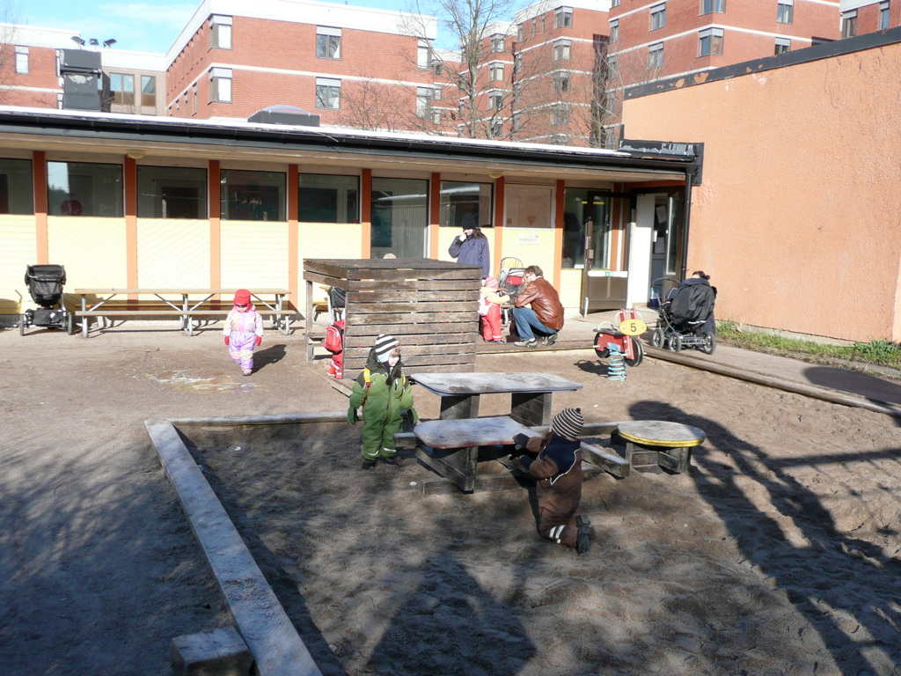

Library Info for Phd students

