Bridge the Gap with People’s Perspectives on Wheelchair Provision

Authors:
Ksenia Cheban BA (Hons) Medicinal Chemistry, MSc OT candidate
Affiliations: University of Limerick, Ireland
Rosemary Joan Gowran PhD, MSc OT, BSc (Hons) OT

Affiliations: Health Research Institute, University of Limerick, Ireland, University of the Sunshine Coast, Queensland, Australia

Introduction
An appropriate wheelchair is a priority assistive technology, enhancing physical and mental health and wellbeing, enabling participation and inclusion (World Health Organization 2008; Salminen et al. 2009; Mortenson et al. 2012; World Health Organization 2017). It consists of five components: a wheelchair must meet the person’s needs and environmental conditions, provide proper fit and postural support, be safe and durable, be available in the country and be maintained affordably within the country (World Health Organization 2008). The consequences of an inappropriate wheelchair can be serious and could lead to death. The World Health Organization is working to promote appropriate access to this vital technology (Cooper 2017).
The provision of an appropriate wheelchair is a complex and multifaceted process comprising of design, production, supply and service delivery, where the needs of service users should to be taken into account at every stage (World Health Organization 2008). Flexibility is required to achieve the same result in different contexts and countries as these may differ greatly (MacLachlan 2018).
This research focuses on the Irish context, where one in one hundred people require wheelchairs. Evidence suggests a wheelchair service delivery system, lacking policies, guidelines and uniformity (Gowran et al. 2014). The aim of the research is to explore people’s perspectives as wheelchair users on the provision of wheelchair services in the Republic of Ireland.

Learning Objectives
1. To understand the perspectives of people with varying neurological conditions on wheelchair and seating provision services.
2. To reflect on wheelchair provision processes within context
3. To recognize the needs of people requiring wheelchairs with varying health and social care challenges across the life course.

Methodology
An in-depth qualitative exploration of wheelchair provision in the Republic of Ireland from a wheelchair service users perspective (n=18) was conducted. People with spina bifida, muscular dystrophy, and spinal cord injuries participated. Semi-structured interviews were transcribed verbatim and analyzed using thematic analysis via NVivo (Terry et al. 2017). Ethical approval from the University of Limerick (2015_05_19EHS) was granted.

Findings – People’s perspectives
Using Bronfenbrenner’s ecological systems theory to frame the research, a number of themes emerged within the micro, meso, exo and macro systems (Onwuegbuzie et al. 2013) relating to the self and wheelchair product, the self and personnel in the provision service and the self the provision process. These include “your chair is your life”, “it depends on the occupational therapist” and “being disabled [wheelchair user] is hard work” (Figure 1). Subthemes highlighted the people’s perspectives on the meaning ascribed to their wheelchair, the effect of the wheelchair provided on health and participation and the significance of the relationship with the occupational therapist, the importance of therapist knowledge, the necessity for self-advocacy and personal skills to receive the service.
Figure 1
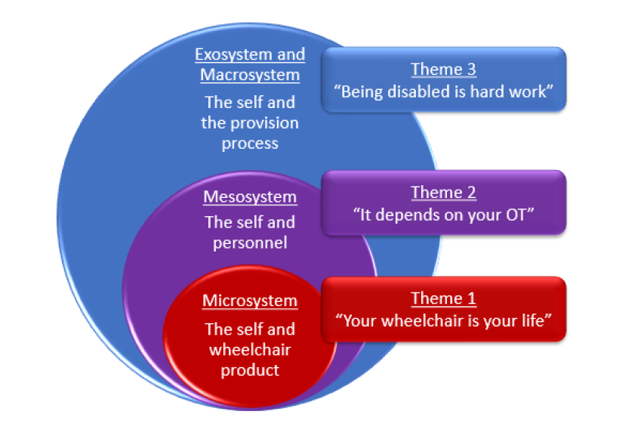Conclusion
Themes highlight the facilitators and barriers to participation, the client therapist relationship, disparity in service provision and the need for future developments. The study encapsulates the importance of the wheelchair to an individual’s life and the impact provision processes have on a person’s occupational engagement and potential to flourish (Toro et al. 2012; Ripat et al. 2017; Toro et al. 2017)
There is a need to review the current wheelchair and seating provision system in the Republic of Ireland. Uniformity in this multifaceted process, advocating to meet the individual needs of people requiring wheelchairs with varying health and social care challenges, across the life course, weather from birth, progressing or traumatic neurological conditions, is recommended (Gowran et al. 2014; Gowran et al 2017; MacLachlan et al. 2018).

References
Cooper, R.A. (2017) 'Commentary on WHO GATE Initiative', The Journal of Spinal Cord Medicine, 40(1), 2-4.
Gowran, R.J., McKay, E.A. and Regan, B. (2014) 'Sustainable solutions for wheelchair and seating assistive technology provision: Presenting a cosmopolitan narrative with rich pictures', Technology and Disability, 26(2-3), 137-152.
Gowran, R. J., Casey, J., & Daly, J. (2017). Utilising a sustainable community of practice model to build best practice in wheelchair provision on the Island of Ireland. In Occupational Therapy Without Borders: integrating justice with practice. Elsevier Health Sciences.
MacLachlan, M., Banes, D., Bell, D., Borg, J., Donnelly, B., Fembek, M., ... & Hoogerwerf, E. J. (2018). Assistive technology policy: a position paper from the first global research, innovation, and education on assistive technology (GREAT) summit. Disability and Rehabilitation: Assistive Technology, 1-13.
Mortenson, W.B., Miller, W.C., Backman, C.L. and Oliffe, J.L. (2012) 'Association Between Mobility, Participation, and Wheelchair‐Related Factors in Long‐Term Care Residents Who Use Wheelchairs as Their Primary Means of Mobility', Journal of the American Geriatrics Society, 60(7), 1310-1315
Onwuegbuzie, A. J., Collins, K. M., & Frels, R. K. (2013). Foreword: Using Bronfenbrenner’s ecological systems theory to frame quantitative, qualitative, and mixed research. International journal of multiple research approaches, 7(1), 2-8.
Ripat, J., Verdonck, M. and Carter, R.J. (2017) 'The meaning ascribed to wheeled mobility devices by individuals who use wheelchairs and scooters: a metasynthesis', Disability and rehabilitation. Assistive technology, 1.
Salminen, A. L., Brandt, Å., Samuelsson, K., Töytäri, O., & Malmivaara, A. (2009). Mobility devices to promote activity and participation: a systematic review. Journal of rehabilitation medicine, 41(9), 697-706.
Terry, G., Hayfield, N., Clarke, V., & Braun, V. (2017). Thematic analysis. The Sage handbook of qualitative research in psychology, 17-37.
Toro ML, Eke C, Pearlman J. The impact of the World Health Organization 8-steps in wheelchair service provision in wheelchair users in a less resourced setting: A cohort study in Indonesia Health systems and services in low and middle income settings. BMC Health Serv Res. 2016;16.
Toro ML, Garcia Y, Ojeda AM, et al. Quantitative Exploratory Evaluation of the Frequency, Causes and Consequences of Rehabilitation Wheelchair Breakdowns delivered at a Paediatric Clinic in Mexico. Disability, CBR & Inclusive Development. 2012;23.
World Health Organization. (2008). Guidelines on the provision of manual wheelchairs in less resourced settings.
World Health Organization. (2017). Global research, innovation and education in assistive technology: GREAT summit 2017 report (No. WHO/EMP/IAU/2017.16). World Health Organization.

