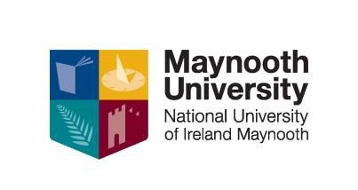

NUI CERTIFICATE IN CRITICAL DISABILITY STUDIES

` Level 7 (20 ECTS)

Critical disability studies is an examination of the systematic discrimination that disabled people face in society. It examines areas like access to employment, transport, housing, cultural depictions of disabled people, in literature, film, TV, the news and the rights of disabled people as enshrined in both national and international law. It takes the focus off the condition (e.g. blindness, cerebral palsy, deafness, down syndrome, etc) and instead aims to look at social attitudes and barriers that prevent disabled people from fully integrating into society. The module will examine the history of disability rights in the US and Europe, and look at the remaining legal, social and attitudinal barriers that are standing in the way of disability equality.

WHO IS THIS QUALIFICATION FOR?
People who wish to learn more about disability and independent living
Disabled People and family members
People working in policy development
People working OR wanting a career in the disability sector.
People working in Social Care, Health Care, Education and Employment professions.
People working with community development providers

DATES, VENUES AND FEES

This course will commence in October 2024 and will be held on full day Saturday and Sunday mornings over 10 weeks during the academic year.
The course fee is €1400 per student. An Easy Payment Plan is available upon registration.

Part time students who are on courses at levels 6 to 10 on the framework of qualifications may be eligible to for the Student Assistance Fund (SAF) to help with the associated costs of attending a university course such as Travel, Childcare, Utilities, Materials etc. Once registered to this course you should first consult: SAF Guidelines to see if you qualify and then e-mail student.budget@mu.ie to make further enquiries.

CPD & PROGRESSION
The NUI Certificate in Critical Disability Studies is a standalone qualification however credits from this course can be used for Recognition of Prior Learning to go towards the Degree in Community Studies.

The Cert. in Critical Disability Studies when combined with the NUI Certificate in Training and Continuing Education (Train the Trainer Level 7) plus the Certificate Equality Studies (Online) entitles students to apply for the award of the Diploma in Arts: Training and Development for Socially Inclusive Workplaces. This suite of CPD courses provide a comprehensive educational/training package in core skills such as managing issues of equality and diversity in the workplace for Team Leaders, Managers and Learning and Development Specialists.

As with all of our level 7 and 8 certificate and diploma courses credits gained on this course can be used for Recognition of Prior Learning on MH101 and MH803.

CONTACT US
Further details will be available in May 2024 Kay Loughlin at kay.loughlin@mu.ie or ring 01 708 6062 . You can also visit our website: https://www.maynoothuniversity.ie/adult-and-community- education/our-courses

