Maynooth University  National University of Ireland, Maynooth  Maynooth, Co. Kildare, Ireland  School of Modern Languages, Literatures and Cultures  Scoil na Nua-Theangacha, na Litríochta agus na gCultúr | 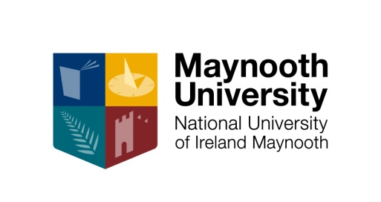

Language Exemption Form

Student Name: __________________________________
Student Number: __________________________________

This is to confirm that the named student is exempt from the attendance of the following module:
Module Number: _________________________
Academic Year: _________________________
Semester: _________________________

Reason: ________________________________________________________ (e.g. native speaker)

Additional stipulations: ____________________________________________________________ (e.g. subject to satisfactory completion of certain assignments /submission of documents)

Please Note:
(a) This exemption does not extend to any form of official assessment, neither Continuous Assessment nor assignments nor end-of-semester examinations (incl. Orals). The exemption is granted at the student's request; the student does not have any redress regarding material covered or information given in the missed classes. It is the student's responsibility to find out when assessments take place / deadlines for assignments, and to fulfil all assessment requirements of the module (general rules re medical certs etc. apply).
(b) The exemption is valid only for the module and for the academic year / semester named above. It is valid for all components of the module (eg. language classes, conversation classes, Language Centre classes) with the exception of sessions in which assessments are held. One copy of this form should be kept by the student, the other copy will be kept on file until graduation.

______________ (date) _______________________________ (signature, module convener)

______________ (date) _______________________________ (signature, year coordinator)

______________ (date) _______________________________ (signature, Subject Leader/HoS)

