Academic Timetable Guide

Note for 2021/22 academic year – Covid-19 continues to have an impact on the academic timetable. Timetable details are subject to change. Semester two is under review, and is very much subject to change.
Please follow the guide below in conjunction with the general guidance on the coming academic year, available at: https://www.maynoothuniversity.ie/coronavirus/students.

The timetable Viewer is available at this Timetable :: Home - Home (maynoothuniversity.ie)
It presents the following ‘views’ of the timetable.
1) Lectures - allows you to search by course e.g. BACHELOR OF ARTS 1 (MH101)
2) Venues – allows you to search to see what’s in a room at a given time (more relevant for academic departments than students)
3) Departments – allows you to see every activity i.e. both Lectures and Tutorials for the Department
4) Students – this is a personalised timetable that you need to log in to view. There is work involved in allocating students to classes to make the personalised timetable work and this takes some time. The personalised timetable will not be available for continuing students until the week of 13th September 2021 – exact date will be advised on the personalised timetable tab. First years will not have access to a personalised timetable until the week of the 20th September 2021
There are guides and useful information available at the bottom of the page.

In general tutorials and practicals are not displayed on the timetable. This is to avoid confusion as there may be multiple offerings of tutorials but each student typically only needs to attend one. The relevant Department can advise you in relation to both tutorials and practicals.

How to view your Timetable
Prior to Registration the best way to view your timetable for the year is to click on “Lectures”.
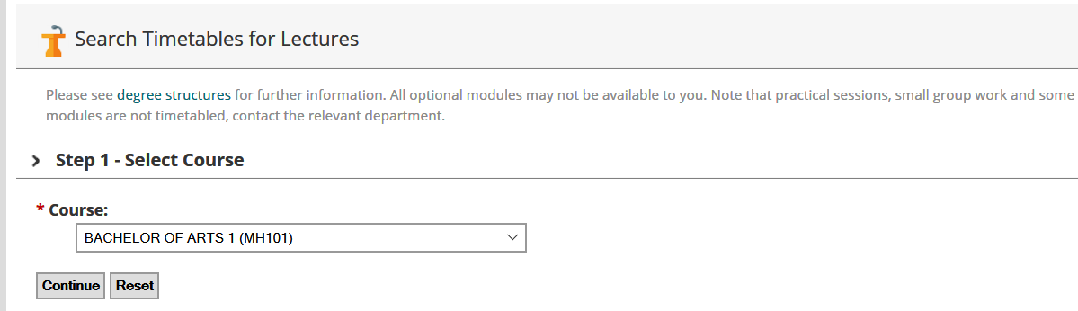

STEP 1: Select Course
Click on the arrow to the right of the box to display a list of courses and select the course you are interested in then click “Continue”.
Note: “Course” refers to a programme of study, for example BA Media Studies 1 (MH109) refers to the Bachelor of Arts (BA) for the course Media Studies for first year (1). The CAO code is included in brackets at the end.

STEP 2: Select Period

We recommend you select Semester one, rather than a week- by- week view. This will give you a better idea of the shape of your timetable. Click the “Continue” button.

Please note that while semester two modules are visible, it is under review and is subject to change.

STEP 3: Select Modules
The modules you choose depends on your other subject choices. Here, Anthropology, Geography, Greek & Roman Civilisation, and History modules have been chosen.
Use the “Ctrl” key if you only want to display particular modules.
Click “Continue” to select all modules. (This will select all available modules – a very long list in 1st Arts)

Step 4: Timetable Display
The timetable will now be displayed as below, showing module code and venue.

For example, on Thursday at 10.00, AN167 takes place in Iontas Theatre [IONTH]
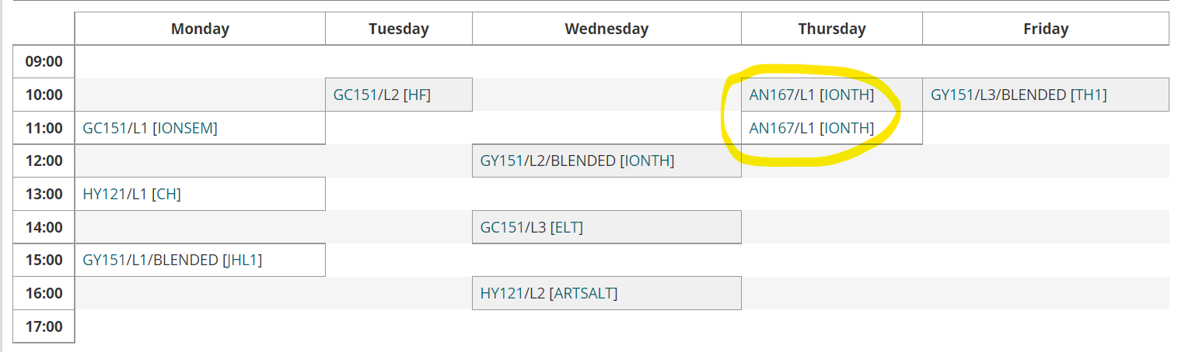

“AN167” is a module code, to get further information about the module, click on it and you will be brought to a page which will give more information about the module. [IONTH] is the venue. If you click on the venue on the timetable, you will be brought to a link with more information. A map of the timetable venues is available here.

Changing your selections: All of the selections you have made in each of the steps above are shown towards the top of the screen. If you wish to change the Course/ Programme/Semester or Module Information displayed you can click the “Change” link, this means you don’t have to go all the way back to the beginning.

Reading the timetable
- L1/L2/L3, etc. refer to Lecture 1, Lecture 2, Lecture 3. Most first year modules have either 2 or 3 lectures per week and students typically need to attend all of these. In 2021, some departments may make arrangements to have some students attend on a rota basis; this will be indicated in the module with BLENDED.
- Information will be provided by the relevant academic department, but in the meantime, guidance information is available in the Studying in Maynooth University in Academic Year 2021-22 document.
- T1/T2 or TUT1, TUT 2 refers to tutorials. (In general students do not need to attend all of these, but will have a choice about which to attend – see your academic department for further information)
- P1, P2, P3 refers to practicals. These are managed by the relevant academic department.
- Where /A or /B or /C appears after the Module code, that means the module is delivered more than once, e.g. MN151. You will be allocated to one of the groups, and will attend either A or B for each lecture.
- Allocation depends on your other modules, when they are timetabled, the department’s requirements and the available capacity in each group.
- You will only see the classgroups relevant to you on your personalised timetable.
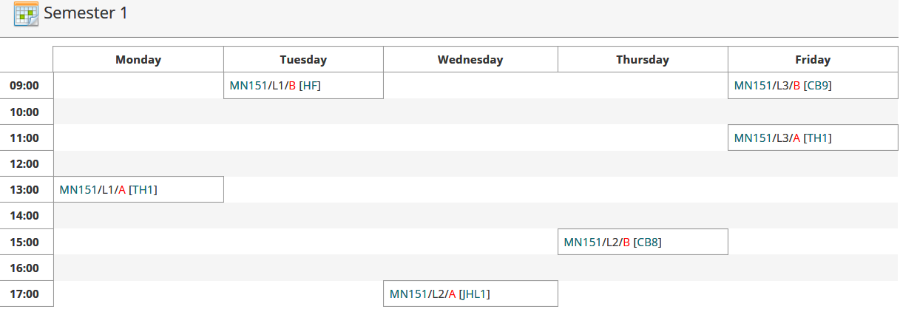

- This classgroup allocation feeds into Moodle, the University’s Virtual Learning environment, within 2-3 working days. This can take longer at the start of the year.
- Changing module choices may result in changes to classgroups.

BLENDED and ONLINE: Some modules will be delivered with a mix of online and in-person attendance. The relevant academic department will advise when you need to attend lectures. If a module indicates ONLINE as the venue, that means the lectures are delivered online.
In all cases where ONLINE lectures are used, departments also have in-person tutorials and/or practicals, where in-person attendance is expected. These will not necessarily show on the timetable.

To view your personalised Timetable – Select the Student Tab
Note: Personalised student timetables are only available after registration, are not available to most postgraduates, and will not be available until later in September, closer to the start of term. The date will be noted on the personalised timetable tab.
- Enter your student number and password (NOTE: the personalised timetable does not work if your password includes a space bar as a character)

- 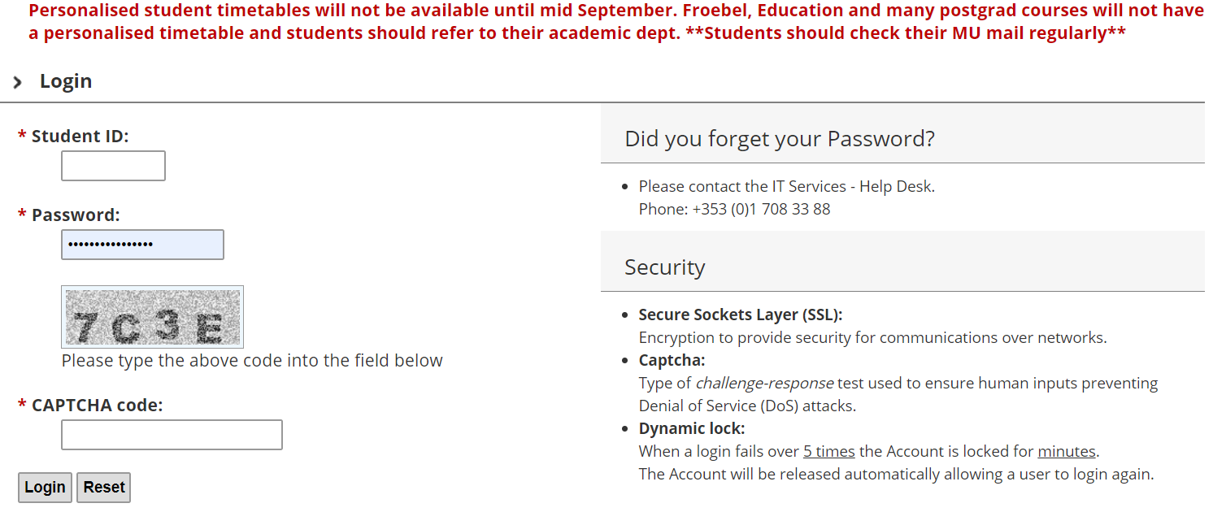

- Enter the CAPTCHA code as you see it in the grey box

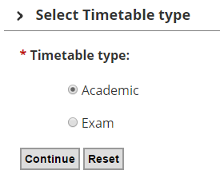
Choose ‘Academic’ and press Continue
You will then be brought to your personalised Timetable. If you do not see anything, that is because either you have not registered yet, we do not schedule your module centrally or work is ongoing to allocate you to see your personalised timetables.
Please be aware that practicals and tutorials are not generally shown on the personalised timetable and you will need to contact the relevant Academic Department in relation to these.

Further questions?
If you have questions that are not answered above, Email Timetable@mu.ie with a clear query and please include your student number in all correspondence.
While we will do our best to answer queries, we will not have detailed information in relation to lecture rotations and may need to refer some queries onto academic departments.
There will be delays in response times during the registration season. We also have an ‘ASK’ button.

