Academic Timetable Guide
Please note that most postgraduate courses are not timetabled centrally; please contact the relevant academic department for further details.
Timetable details are subject to change.
The Timetable Viewer is available at this Timetable :: Home - Home (maynoothuniversity.ie)
This allows students to view when modules are scheduled. It should be used in conjunction with the programmes and modules outlined on Course Finder
The Timetable Viewer presents the following ‘views’ of the timetable.
1) Lectures - allows you to search by course e.g. BACHELOR OF ARTS 1 (MH101)
2) Venues – allows you to search to see what’s in a room at a given time (more relevant for academic departments than students)
3) Departments – allows you to see every activity i.e. both Lectures and Tutorials for the Department
4) Students – this is a personalised timetable that you need to log in to view. This is not available for 2022/23 yet.
Students need to be registered to modules before personalised timetables will work. Additional tasks involved in allocating students to classes to make the personalised timetable work and this takes some time.
The personalised timetable will not be available for continuing students until the week of 12th September 2022 – the exact date will be advised on the personalised timetable tab. First years will not have access to a personalised timetable until the week of the 20th September 2022 as registration does not happen until just before that week.
There are guides and useful information available at the bottom of the timetable webpage.

In general tutorials and practicals are not displayed on the timetable. This is to avoid confusion as there may be multiple offerings of tutorials but each student typically only needs to attend one. The relevant academic department can advise you in relation to both tutorials and practicals.

How to view your Timetable
Prior to Registration the best way to view your timetable for the year is to click on “Lectures”.
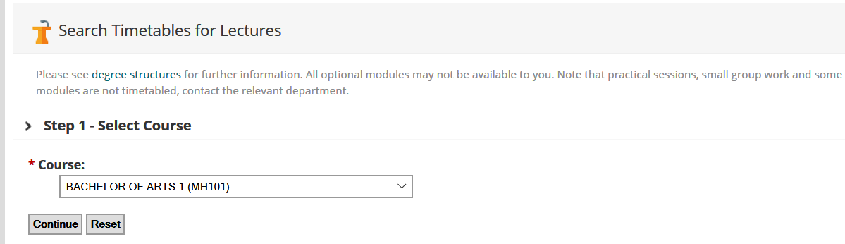

STEP 1: Select Course
Click on the arrow to the right of the box to display a list of courses and select the course you are interested in then click “Continue”.
Note: “Course” refers to a programme of study, for example BA Media Studies 1 (MH109) refers to the Bachelor of Arts (BA) for the course Media Studies for first year (1). The CAO code is included in brackets at the end.

STEP 2: Select Period

We recommend you select Semester one, rather than a week- by- week view. This will give you a better idea of the shape of your timetable. Click the “Continue” button.

Please note that while semester two modules are visible, it is under review and is subject to change.

STEP 3: Select Modules
The modules you choose depends on your other subject choices. Here, Anthropology, Geography, Greek & Roman Civilisation, and History modules have been chosen.
Use the “Ctrl” key if you only want to display particular modules.
Click “Continue” to select all modules. (This will select all available modules – a very long list in 1st Arts)

Step 4: Timetable Display
The timetable will now be displayed as below, showing module code and venue.

For example, on Thursday at 10.00, AN167 takes place in Iontas Theatre [IONTH]
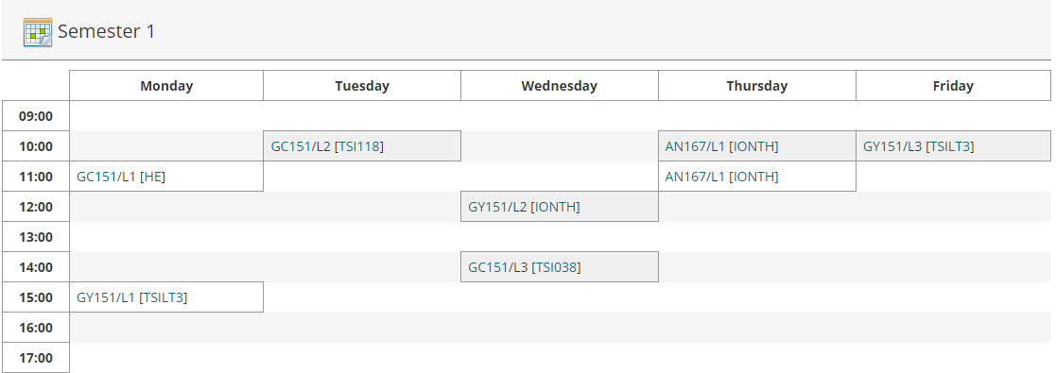

“AN167” is a module code, to get further information about the module, click on it and you will be brought to a page which will give more information about the module.
[IONTH] is the venue.

Changing your selections: All of the selections you have made in each of the steps above are shown towards the top of the screen. If you wish to change the Course/ Programme/Semester or Module Information displayed you can click the “Change” link, this means you don’t have to go all the way back to the beginning.

Reading the timetable
- L1/L2/L3, etc. refer to Lecture 1, Lecture 2, Lecture 3. Most first year modules have either 2 or 3 lectures per week and students typically need to attend all of these.
- T1/T2 or TUT1, TUT 2 refers to tutorials. (In general students do not need to attend all of these, but will have a choice about which to attend – see your academic department for further information)
- P1, P2, P3 refers to practicals. These are managed by the relevant academic department.
- Where /A or /B or /C appears after the Module code, that means the module is delivered more than once, e.g. MN151. You will be allocated to one of the groups, and will attend either A or B for each lecture.
- Allocation depends on your other modules, when they are timetabled, the department’s requirements and the available capacity in each group.
- When the personalised timetable is available, you will only see the classgroups relevant to you on your personalised timetable.
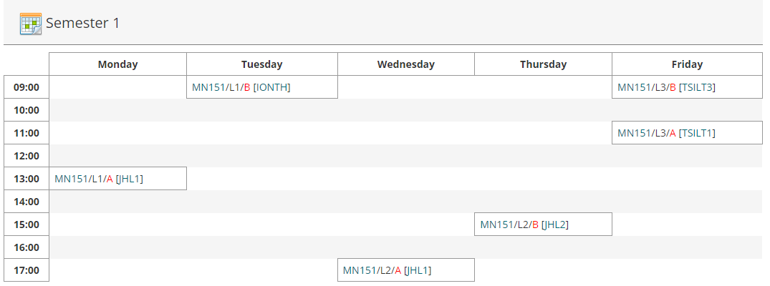

- This classgroup allocation feeds into Moodle, the University’s Virtual Learning environment, within 2-3 working days. This can take longer at the start of the year.
- Changing module choices may result in changes to classgroups.

To view your personalised Timetable – Select the Student Tab
Note: Personalised student timetables are only available after registration, are not available to most postgraduates, and will not be available until later in September, closer to the start of term. The date will be noted on the personalised timetable tab.
- Enter your student number and password (NOTE: the personalised timetable does not work if your password includes a space bar as a character)

- 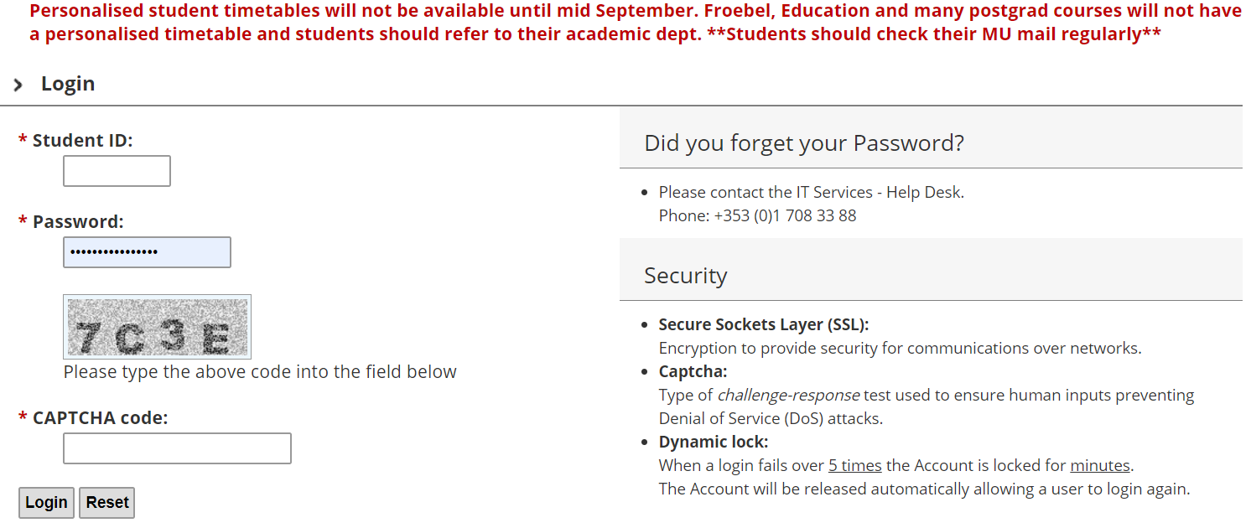

- Enter the CAPTCHA code as you see it in the grey box

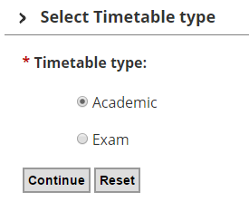
Choose ‘Academic’ and press Continue
You will then be brought to your personalised Timetable. If you do not see anything, that is because either you have not registered yet, we do not schedule your module centrally or work is ongoing to allocate you to see your personalised timetables.
Please be aware that practicals and tutorials are not generally shown on the personalised timetable and you will need to contact the relevant Academic Department in relation to these.

Further questions?
If you have questions that are not answered above, Email Timetable@mu.ie with a clear query and please include your student number in all correspondence.
While we will do our best to answer queries, there may be delayed response times during the registration season. We also have an ‘ASK’ button.

