National University of Ireland, Maynooth
DEPARTMENT OF HISTORY

FLYERS FOR OPTIONAL MODULES

III ARTS SEMESTER 2 2023-24

PLEASE NOTE

Flyers provide information supplementary to that available in module descriptors, which may be viewed on the university database at www.maynoothuniversity.ie/courses.

Students are expected to consult both flyers and module descriptors, as well as the academic timetable, in advance of registration.

national university of ireland, maynooth
department of history
third arts, 2023-24
Second Semester
Lecturer  dr joanne mancini | Module code HY 305 | Credits  5 | Lecture hours per week  Two

Module title

ENVIRONMENT AND CULTURE IN AMERICAN HISTORY

Module content
This module explores the relationship between people and the environment as an aspect of American history. Drawing on environmental, cultural, political, and social history, it will examine how this relationship, and conceptions of it, have changed over time.

Form of Assessment:
Participation 10%
In-class group presentation (digital assignment) 15%
In-class quizzes (3 x 5%) 15%
3000-word essay 60%
Deadline for submission of essay: 13 May 2024

Special requirements (e.g. field trips inc. costs, special sessions)
Required text: McKibben, ed., American Earth)
national university of ireland, maynooth
department of history
Third arts, 2023-24

Second Semester
Lecturer  PROFESSOR FILIPE RIBEIRO DE MENESES | Module code HY 315 | Credits  5 | Lecture hours per week  Two

Module title

Hitler’s Europe, 1939-1945 (B)

Module Content
This module is the second part of a year-long examination of the European continent during the Second World War, following on from HY 314 in the first semester (although it can be taken on its own). Its focus is on how the governments and peoples of Germany’s allies, neutral states and occupied territories adapted themselves to Nazi aims and the course of the conflict. Special attention is paid to the questions of collaboration and resistance, and their long-term consequences for countries in question and Europe in general.

Module Aim and Objectives:
Aim:
- To acquire a deeper understanding of the link between wartime collaboration with and resistance to Nazi aims and subsequent European history.

Objectives:
- To introduce students to the process of writing History at a higher level, involving regular supervision by the course lecturer;
- To enable students to identify the sources needed for their assessment;
- To promote amongst students the awareness of academic work as a collective enterprise.

Module Structure:
This module will be seminar-based, with an emphasis on student presentation and discussion of ongoing work as part of the preparation for a final essay.

Form of assessment

This module is entirely based on continuous assessment. Marks are given for participation in class discussions, a number of tasks essential for the preparation of the final essay, and the essay itself (3,500 words).

national university of ireland, maynooth
department of history
third arts, 2023-24

Second Semester
Lecturer  DR DAVID LEDERER | Module code HY 354 | Credits  5 | Lecture hours per week  Two

Module title
THE HOLY ROMAN EMPIRE, 1648-1806

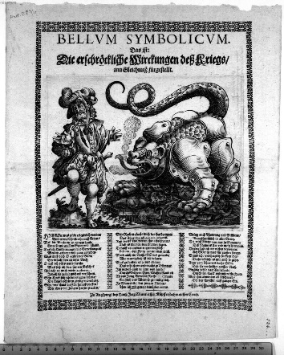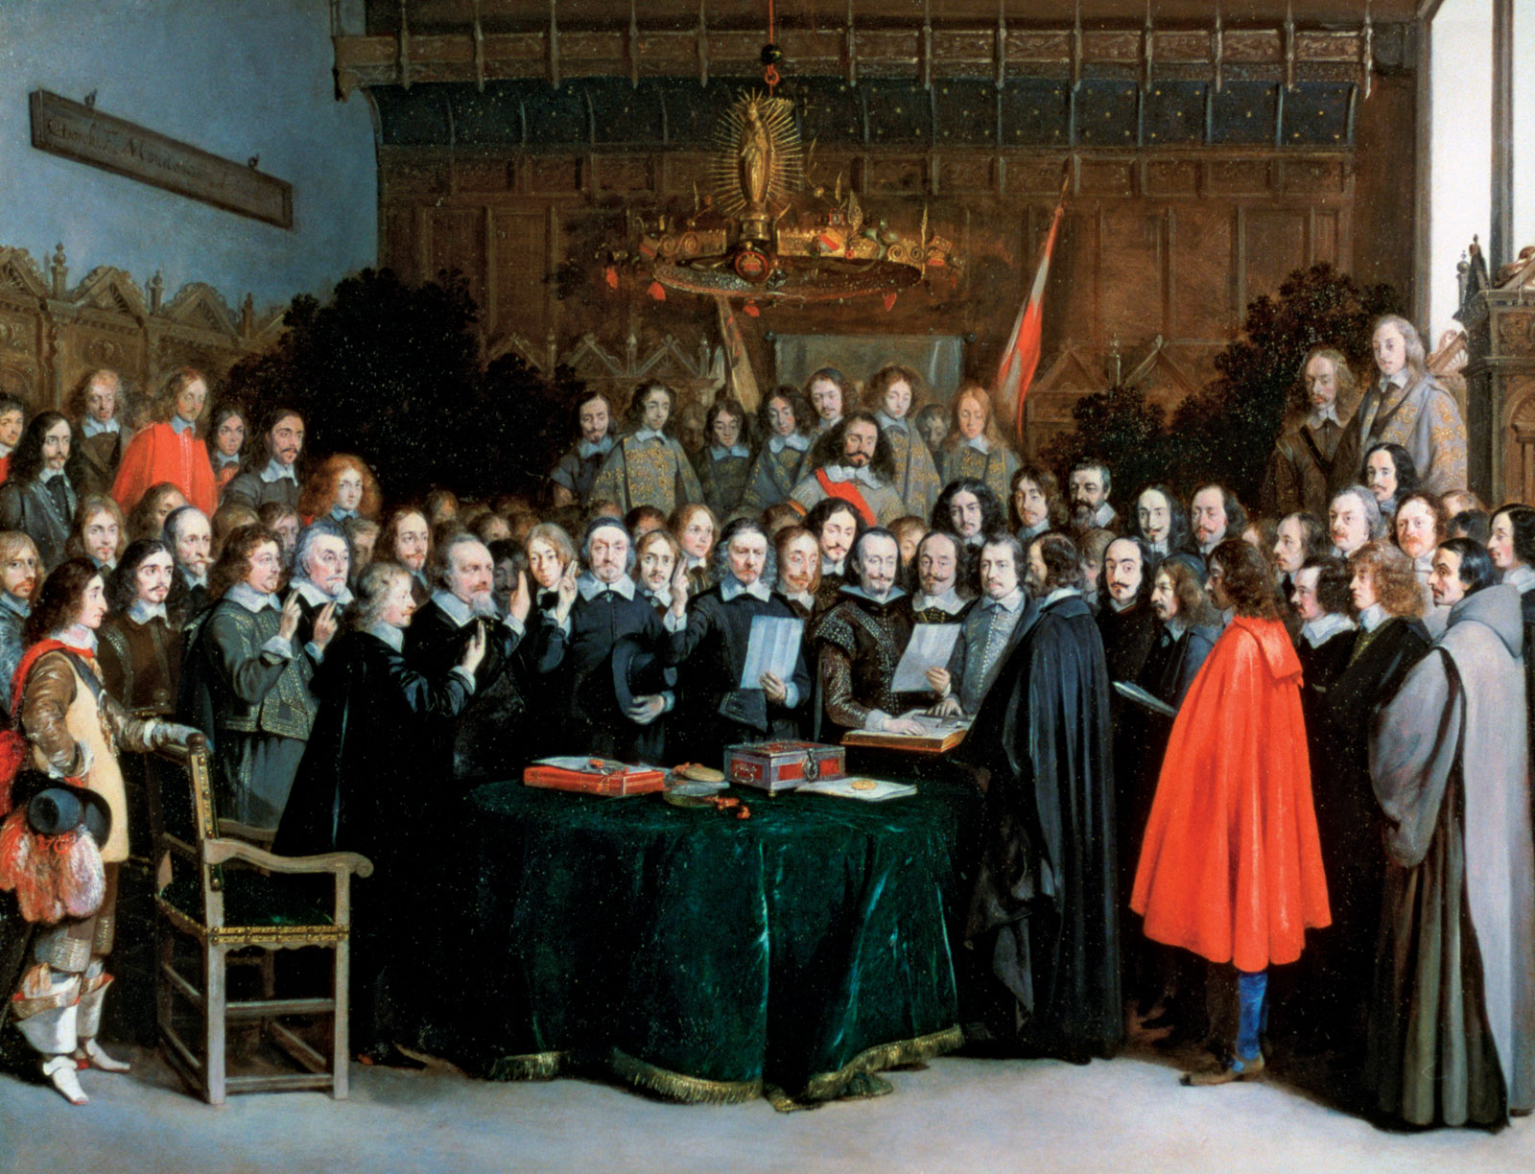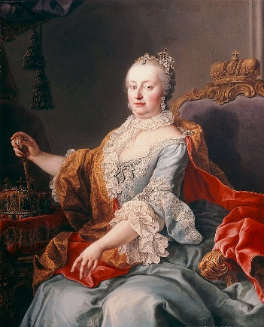

MODULE CONTENT

This is part two of the Holy Roman Empire super-elective, which follows on from HY353 in the first semester. However, attendance at HY 353 is not a prerequisite to taking this course. It begins with an extended analysis of the Thirty Years War from political and social perspectives and the impact of the Peace of Westphalia on Europe. Subsequently, we examine mounting tension between Prussia and Austria and events leading to the final dissolution of the Empire in 1806. Finally, students are introduced to differing historical interpretations of the Empire from German, European and Global perspectives. Students participate actively in a series of in-class discussions, presentations of historical documents and oral book reviews, posting to a group website and composing an essay for submission at the end of the semester.

Form of Assessment

3,000 word essay 60%
In-class assignments/tests 40%
Deadline for submission of essay is Monday, 13 May 2024
national university of ireland, maynooth
department of history
third arts, 2023-24

Second Semester
Module Co-ordinator  DR DYMPNA MC LOUGHLIN | Module code  HY 390 | Credits  5 | Lecture hours per week  Two

Module title:

SOCIAL HISTORY OF HEALTH IN NINETEENTH AND TWENTIETH CENTURY IRELAND

Overview
The module will introduce students to the key aspects of the social history of medicine in nineteenth century Ireland. It will document the journeys of ordinary Irish men, women and children through ill health, and how they negotiated their way through various medical institutions. The medical profession will also be documented, as well as how the profession interpreted and treated various illness and diseases, not always successfully.

Course Themes
- The nineteenth century medical world
- Medical institutions in the nineteenth century.
- Illness with stigmas attached to them such as aids, tuberculosis and syphilis.
- Smallpox in Ireland
- Cholera in Ireland 1832 and 1847-52.
- Mental health and the and the implications of the Dangerous Lunatics Act 1838
- The adulteration of alcohol and its devasting impact on human health- case studies of whiskey, poteen and ether.

Form of Assessment
Class Participation 10%
Class Presentation 20%
Essay of 4,000 words on primary source 70%
Deadline for submission of essay is Monday, 13 May 2024

national university of ireland, maynooth
department of history
third arts, 2023-24
Second Semester
Lecturer  PROFESSOR MARIAN LYONS | Module code HY 393 | Credits  5 | Lecture hours per week  Two

Module title
IRISH MIGRANTS IN THE EARLY MODERN WORLD

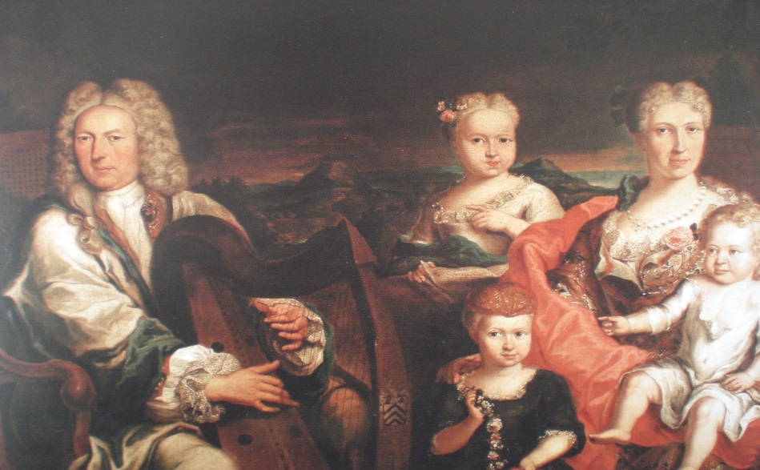

Module content
Between c.1600 and c.1820, a great variety of motives caused men and women to leave Ireland for Continental Europe and further afield. The lure of education, employment, prosperity and religious tolerance was especially strong, but so too was the desire for adventure and change, and a dislike of the isolation associated with living at the extreme periphery of Europe. By the mid-seventeenth century, the Irish had achieved unprecedented visibility on the Continent: on the battlefields, in the docks of major ports, in the university lecture halls, in royal courts, on the streets and even in the hospitals, prisons and galley ships. Between c.1600 and c.1820 many Irish made significant contributions to their host societies in Europe and through service in the overseas colonial administrations of Europe’s major powers, especially in the realms of war, politics, diplomacy, medicine, and trade (including slavery and the East India Company). Drawing upon secondary and primary source material, this module explores their diverse experiences in various parts of Europe and as far afield as the Caribbean.

Form of Assessment
Research project (4,500 words approx.), topic to be agreed upon in advance with lecturer 80%
Primary source analysis (500 words approx.) submission mid-term 10%
Participation 10%
Deadline for submission of research project: Monday, 13 May 2024

national university of ireland, maynooth
department of history
third arts, 2023-24
Second Semester
Lecturer  DR JENNIFER REDMOND | Module code HY 395 | Credits  5 | Lecture hours per week  Two

THE IRISH IN BRITAIN: TWENTIETH CENTURY

Module Content
Historically, we know quite a bit about the successes, failures, and experiences of the Irish in North America, but what about those who went to places closer to home? Britain was a quicker, cheaper, less hazardous place to migrate to and became popular as a destination for Irish migrants in the twentieth century, but were they welcome? What did they do? Where did they live? This module examines the lives of the Irish in twentieth-century Britain, comparing the life opportunities offered in both countries and hence the reasons why so many thousands of young people left. Work experiences for men and women are analysed, including during the Second World War when Irish people worked in the British home front industries as well as the armed forces, a history that calls into question the idea of Irish neutrality. Irish experiences of discrimination are also examined, particularly in the context of the IRA campaigns in Britain during the years of the Troubles. More positive narratives of career success are also interrogated, in particular the differing career paths of Irish men and women in Britain. We will use personal accounts such as memoirs and oral histories as well as wider social historical material including newspapers and statistical information to examine issues of health, employment, identity and education for the second generation Irish.
Students will work independently and in groups throughout this course on a range of assessments that will expose them to the use of primary sources. They will also gain experience in choosing their own topic for research for the final essay.

Form of Assessment:
In-class presentation 20%
Participation grade 10%
Essay (3,500 words) 70%
Deadline for submission of essay: Monday, 13 May 2024

Special requirements (e.g. field trips inc. costs, special sessions)
Required text
Enda Delaney, Demography, State and Society (Liverpool University Press, 2000)
Available as an ebook from Maynooth Library

national university of ireland, maynooth
department of history
third arts, 2023-24
Second Semester
Lecturer  PROFESSOR DEJAN DJOKIĆ |  | Module code  HY 3025 | Credits  5 | Lecture hours per week  Two
Module title

EUROPE IN THE AGE OF REVOLUTION AND NATION, 1789-1878

Historians have traditionally approached the age of revolution in 19th century Europe from a western-centric perspective, but this module looks at both eastern and western Europe. The broader context of European (France and the Napoleonic wars) and Middle Eastern (Ottoman Egypt and Syria) revolutionary upheavals of the late 18th and early 19th century helps explain the fragmentation of the Ottoman political space and the outbreak of Serb and Greek ‘revolutions’. The students will also explore the (failed) 1830 Polish revolution; the impact of the 1848 revolutions on East-Central Europe; the wider, pan European significance of Italian and German unification movements; and the Ottoman, Habsburg and Russian rivalry during the ‘Great Eastern Crisis’ of the 1870s.

Assessment
5,000-word essay or shorter essay combined with other assessment during semester.
Breakdown to be confirmed.
Deadline for submission of essay: Monday, 13 May 2024
NATIONAL UNIVERSITY OF IRELAND MAYNOOTH
DEPARTMENT OF HISTORY
THIRD ARTS 2023-24

Second Semester
Lecturer | Module code SG354 | Credits  5 | Lecture hours per week

Module title
HISTORY 5 – THE VIKING WORLD II: IRELAND

as per Course Finder, July 2023

Overview
Vikings occupy an important place in the modern cultural imagination, but who exactly were they and what impact did they have in Ireland? This module explores representations of the Vikings in medieval sources and popular culture, shedding light on their origins, their first raids on Ireland from the late eighth century and their later settlements on the island. This module will explore questions of ethnic identity, immigration, gender, urbanisation and the cultural legacy of Vikings in Ireland and the wider medieval world. The historical reality of the Vikings will be contrasted with their representation in films and TV shows in the modern era.

24 lecture hours

Form of assessment
Assessment type | Weighting | Duration
Continuous Assessment | 50%
University scheduled written examination | 50% | 60 minutes

Please note that SG354 is timetabled by the Department of Early Irish (Sean-Ghaeilge) and may clash with core lectures in other subjects.

