MU – UDL & U

What is Universal Design for Learning (UDL)? Principles and Guidelines

What is Universal Design?

Universal Design for Learning is derived from the concept of Universal Design, which in physical environments means ‘designing-in’ maximum access for the most amount of people from the earliest stages of the project.

What is Universal Design for Learning?

Universal Design for Learning (UDL) aims to create educational environments that do the same. UDL is best described as a framework of principles and values that can be used as part of an institutional, departmental and/or individual educator approach to inclusive education. The UDL Framework, originated with CAST, Inc., The Center for Applied Specialized Technology, but has subsequently been elaborated to address multiple intersectional barriers to learning.

The core idea behind UDL is the recognition that students are different in terms of their motivations, learning preferences, abilities, and needs. The UDL framework aims to eliminate unnecessary barriers to the learning experience. It provides a set of principles and guidelines that encourage educators to adopt an inclusive mindset, considering how students experience learning in a course and addressing challenges that different students may face.
UDL can be used as part of an institutional, departmental and/or individual educator approach to inclusive education.

What are the UDL Principles?

There are three UDL principles. The principles facilitate educators in breaking down the inclusive design approach into bite-sized processes that allow practitioners to work step-by-step, rather than be overwhelmed.

- Multiple Means of Engagement

Understanding that students have different motivations, challenges to learning, and interests, this principle underscores the importance of providing varied opportunities for engagement. By offering choices and incorporating a range of strategies, educators can tap into students' interests, sustain their attention, and foster a positive and supportive learning environment.

Examples:

- Access note: Invitation to use the learning space in a manner that suits the student
- Make an introduction video for students to view before starting your course
- Embed time to invite different perspectives related to the topic or goal

- Make it relevant
- Read the room (social emotional contexts, life)
- Embed movement/comfort breaks

- Multiple Means of Representation

Recognising that students have different ways of perceiving information, this principle emphasizes the importance of presenting content in various ways. Providing diverse modes of representation ensures that students can access information through different sensory channels, such as visual, auditory, and tactile methods. Furthermore, educators need to consider the materials used to ensure that students see themselves and others represented, bringing relevance and value to their learning.

Examples

- Subtitles on presentation (language options)
- PowerPoint Live
- Accessible font style and size
- Visuals: relevant and alt text/image descriptor
- Content/Visuals choice: authentic, inclusive, relevant

- Multiple Means of Action and Expression

Acknowledging that students have different ways of expressing their understanding, this principle focuses on offering diverse options for communication and expression. Students are provided with various means to demonstrate their knowledge and skills, accommodating different capacity, approaches to learning and learning preferences.

Examples

- Continuous assessment
- Choice of written, poster, or audio/visual (as assignment gets larger, poster is removed). These are just some examples.
- Flexibility with timelines where feasible
- Opportunities for critical peer feedback

What are the UDL guidelines?

In order to help educators apply the UDL Framework, CAST developed the UDL Guidelines.
There are 9 UDL guidelines. The chart below from CAST outlines the guidelines under the different principles and describes possible ways the educator could apply that guideline. There are checkpoints to help the educator evaluate if they are applying the guidelines.

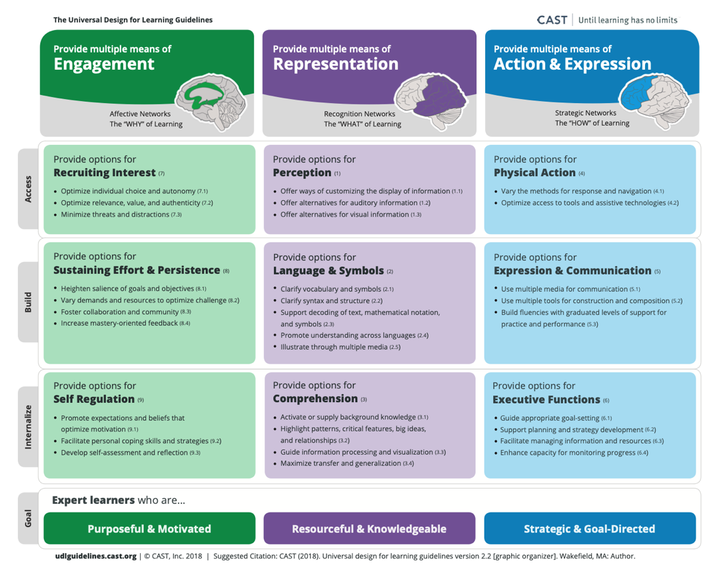
References

CAST (n.d.) ‘UDL Guidelines – FAQ’. Accessible at: https://udlguidelines.cast.org/more/frequently-asked-questions

CAST (2018). Universal design for learning guidelines version 2.2 [graphic organizer]. Wakefield, MA. Accessible at: https://udlguidelines.cast.org/binaries/content/assets/udlguidelines/udlg-v2-2/udlg_graphicorganizer_v2-2_numbers-yes.pdf

How to cite this document
Maynooth University UDL Teaching and Learning Fellows (2024). What is Universal Design for Learning (UDL)? Principles and Guidelines, Maynooth: Centre for Teaching and Learning, Maynooth University.
CC BY-NC-SA: This license allows reusers to distribute, remix, adapt, and build upon the material in any medium or format for noncommercial purposes only, and only so long as attribution is given to the creator. If you remix, adapt, or build upon the material, you must license the modified material under identical terms.

