Submission template
Please download this form before completing it

UDL Symposium 20205 Application Form
Submission deadline: Friday 28 March, by 5pm GMT
Please note: All authors who are presenting must be registered by May 26th, 5pm GMT. Submissions where authors have not registered will be considered withdrawn after this date.
Presentations must be submitted by Monday August 25th

Author 1 name (please only list authors who will be presenting)

Author 1 email

Author 1 bio (200 words max). Please note that bios over 200 words will not be added to the conference brochure.

Author 2 name

Author 2 email

Author 2 bio (200 words max). Please note that bios over 200 words will not be added to the conference brochure3
Author 2 name

Author 3 email

Author 3 bio (200 words max). Please note that bios over 200 words will not be added to the conference brochure

Please add name and email of additional authors who will be presenting. Once paper is accepted we will follow up to get required details.

Type of Presentation
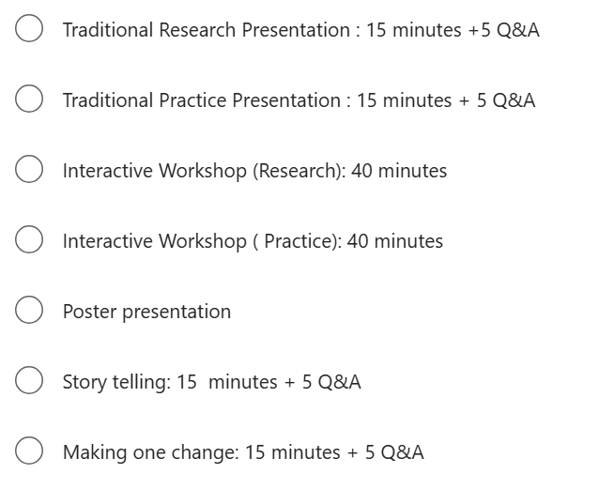
Please Indicate your theme (max 2)
- UDL in practice
- UDL research
- UDL in policy
- Equity, diversity, inclusion and UDL
- Technology for Inclusion
- Emotional Capacity/Wellbeing
- Enacting UDL
- Do you have another idea? We would love to hear about it!

Please indicate your target audience(s)
  - Early Childhood Education
  - Primary
  - Post-Primary/Secondary
  - Further and Higher Education
  - Professional Development
  - Employment
  - Social inclusion
  - Advocacy
  - Professional Learning/Development

Title of presentation

Session abstract (500 words max). Submission guidelines for each session type area available in the Call for Submissions Information Sheet

Plain language description of your session for participant brochure (max 250 words). Please note that this is not a copy and paste of abstract. It is a short descriptor that participants will use to choose their sessions. Submissions without a plain language description will not be accepted.

