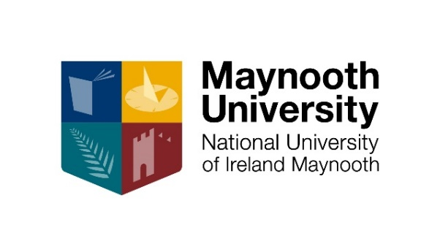
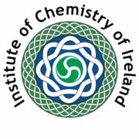

76th Irish Universities Chemistry Research Colloquium
The 76th edition of the Chemistry Colloquium run annually under the aegis of the Institute of Chemistry of Ireland will be hosted this year at Maynooth University on the 16th - 17th June 2025 by the Department of Chemistry.
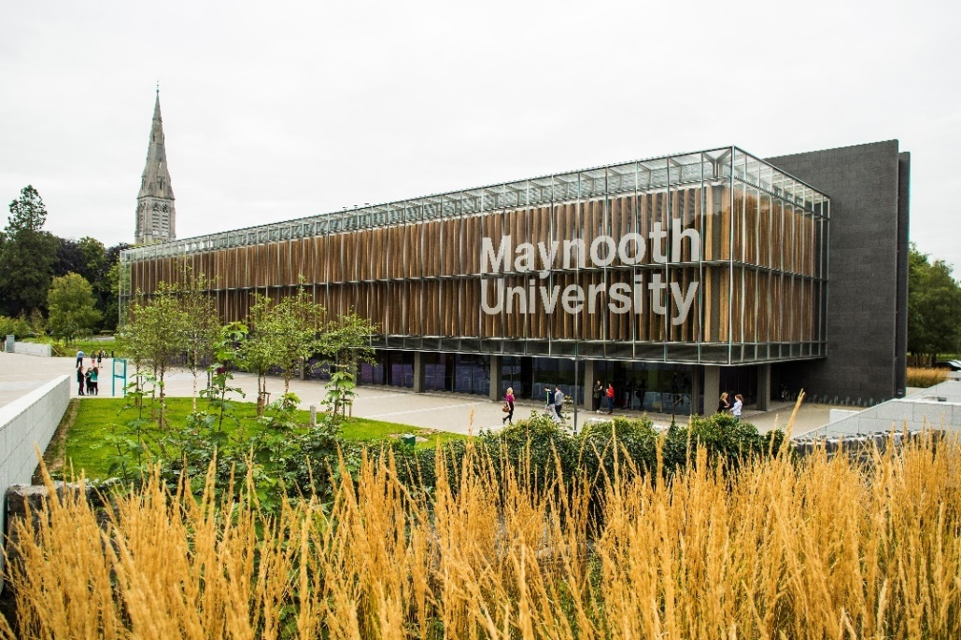
Format for the Colloquium. We will follow the successful format of recent years.
All final year PhD students are welcome to present their research. To achieve this, there will be multiple parallel sessions. For other postgraduate and postdoctoral researchers, there will be a poster session and combined drinks/dinner reception in the evening of the 16th June. All participants will be welcome to a BBQ dinner and drinks at the MSU Building, on campus, in the evening of 16th June.
Plenary Speakers are:
- Professor Steven Bell, Queen’s University Belfast
- Dr Michelle Browne, Helmholtz-Zentrum, Berlin

Registration fee is €50 for postgraduate and postdoctoral researchers, and will include coffee/tea breaks and dinner on the 16th June.

Further details (including Registration) will be available from 28th March, on the 76th ICI Colloquium Website or via the QR code below.


