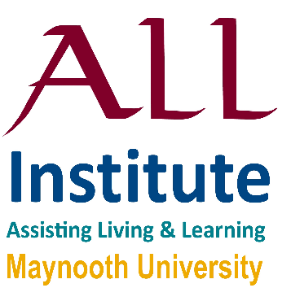

A Symposium

for & by ALL Institute

**2:30 pm - Welcome**

Delia Ferri

ALL Institute

**2:40 pm - Keynote Speaker**

Beth Ferri

Professor of Inclusive Education and Disability Studies at Syracuse University, U.S.

**3:00 pm - Round Table Discussion**

(Facilitator Dr. Delia Ferri)

Beth Ferri (Syracuse University)

David Doyle (Dept. Law, MU)

Delma Byrne (Dept. of Sociology)

Inclusion 2.0: Addressing Inequity & Exclusion within Inclusive Policies & Practices

Thursday 20th June, 2:30-4pm

Hume Board Room, 3rd Floor,

John Hume Building, Maynooth University

**All Welcome**

Light refreshments served

**ALL** Assisting Living & Learning