Law Department

Courses offered in English language

Founded in 1175, the University of Modena and Reggio Emilia lies in one of the most advanced areas in Europe where economic wealth and quality of life have found a unique synthesis.

Here, every student can rely on quality services to seize the best opportuni-ties offered by teaching and research in an area rich in history and excellent products, from car engineering design to food and wine.

The Law Department of the University of Modena and Reggio Emilia offers a wide range of courses taught in English language: some of them can be only attended by Erasmus incoming students.

English courses implemented per
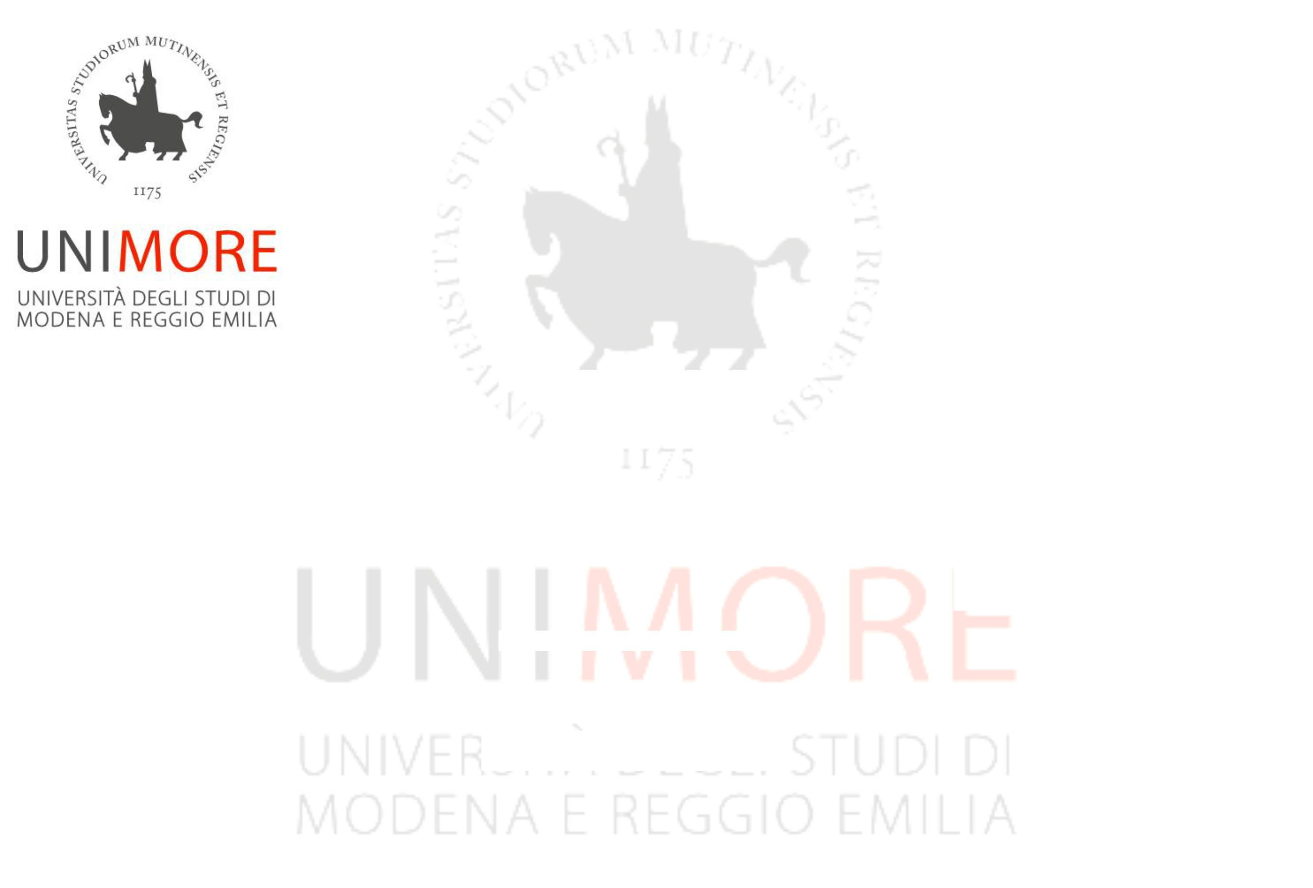
year:

2018 – 2019

1st Semester (September – December)

Introduction to Italian Law (6 CFU,

only for Erasmus incoming students)
European and International Criminal
Law (6 CFU- 42 hours)

Insolvency Law (6 CFU – 42 hours)

Commercial Law (9 CFU – 42 hours), part 1

2nd Semester (February – May)
Introduction to Italian Law (6 CFU,

only for Erasmus incoming students)

Commercial Law (6 CFU – 42 hours), part 2

International Law (9 CFU – 63 hours)

Law and Religion (6 cfu – 42 hours)

Philosophy of Law (9 CFU – 63 hours)

Private Law (12 CFU – 84 hours)

2019 – 2020 onwards

Introduction to Italian Law (6 CFU,

only for Erasmus incoming students)
Commercial Law (15 CFU)
Comparative Human Rights Law (6 CFU)

Criminology (6 CFU)

European and International Criminal
Law (6 CFU)
European and International Tax Law (6 CFU)

Insolvency Law (6 CFU)

International Law (9 CFU)

Law and Religion (6 CFU)
Medical Law (6 CFU)
National and International Arbitration

Law (6 CFU)

Philosophy of Law (9 CFU)

Private Law (12 CFU)

***

For further information

University of Modena and Reggio Emilia, Law
Department
Via San Geminiano, 3 – 41121 MODENA (Italy)

Telephone: +39.059.2058181

E-mail:
luigi.foffani@unimore.it

francesco.belvisi@unimore.it

