Beyond Sexuality: Of Love, Failure and Revolutions by Aislinn O’Donnell in Deleuze and Sex by Frida Beckman

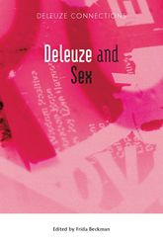

Beyond Sexuality: Of Love, Failure and Revolutions

Aislinn O'Donnell

This chapter explores sexuality as it may be expressed through the relationship between desire and joy and failure. In meetings between the joyful creativity of desire and the failures of the world to keep together, O'Donnell locates a possibility of wrestling sexuality from its familiar meanings and practices and recognising in it a capacity to open us up to joy as well as crisis in situations of new, subterranean forms of community as well as of war and death. Drawing our attention to the sentience of bodies in crisis – in prison, in illness or in dying – O'Donnell brings out physical dimensions of desire that are not Oedipalised. Reading Walt Whitman and Herman Melville in terms of the creative sensibility opened up through camaraderie but also through failure and destruction, this chapter reveals an eroticism that, in the face of depersonification and fragmentation, emerges as receptivity and singularity.

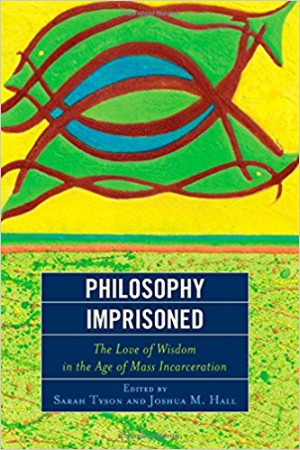
Philosophy Inprisoned The Love of Wisdom in the Age of Mass Inceneration Edited by Sarah Tyson and Joshua M. Hall
Western philosophy’s relationship with prisons stretches from Plato’s own incarceration to the modern era of mass incarceration. Philosophy Imprisoned: The Love of Wisdom in the Age of Mass Incarceration draws together a broad range of philosophical thinkers, from both inside and outside prison walls, in the United States and beyond, who draw on a variety of critical perspectives (including phenomenology, deconstruction, and feminist theory) and historical and contemporary figures in philosophy (including Kant, Hegel, Foucault, and Angela Davis) to think about prisons in this new historical era. All of these contributors have experiences within prison walls: some are or have been incarcerated, some have taught or are teaching in prisons, and all have been students of both philosophy and the carceral system. The powerful testimonials and theoretical arguments are appropriate reading not only for philosophers and prison theorists generally, but also for prison reformers and abolitionists.

Re-Imagining Imprisonment in Europe: Effect, Failures and the Future
Edited by Eoin Carroll and Kevin Warner

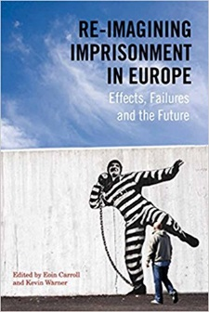
Countries throughout Europe are sending more and more of their citizens to prison, yet this has no correlation with crime figures. Alongside this, people are being sent to prison for longer. It appears too that an increasingly punitive approach to penal policy is being adopted throughout Europe by parties coming from both the left and right of the political spectrum. While there has been an increase in domestic, European and UN prison oversight structures and corresponding pressures to reform prison policy and practice, conditions of imprisonment and the incidence of breaches in standards continue to be a matter of serious concern in many European countries. This book stems from the Scribani international conference organised by the Jesuit Centre for Faith and Justice which was held in Trinity College Dublin. The chapters analyse some of the key features of imprisonment throughout Europe today, including the political, social and economic forces shaping prison policy and practice. Authors explore how people in prison are treated and portrayed and what future imprisonment should look like in terms of policy, population size, prison conditions and most importantly, its use.

O’ Grady, G. (2014) 'Forging a Path through Multiplicity: Rethinking Adolescent Development’ in J.N. O' Higgins (Ed). Education Matters: Readings in Pastoral Care for School Chaplaincy, Guidance and Pastoral Care, pp 69-89. Dublin: Veritas.
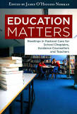

The chapter critically reviews some orthodox theories of identity development in adolescence and examines the assumptions behind these kinds of model building. It asks how they compare with contemporary theorizing about the self and finishes by pointing to new practices in developmental work with young people and presenting a short summary of a psychosynthesis programme for adolescents.

Assessing Impact of ICT Intercultural Work: The Dissolving Boundaries Program by Angela Rickard and Roger S. P. Austin In Exploring the New Era of Technology-Infused Education by L. Tomei (Editor) (IGI Global) 2017.
Recent advancements in technology have led to significant improvements and developments within learning environments. When utilized properly, these innovations can serve as a valuable resource for educators and students.
The article reports on a school-based ICT initiative, called Dissolving Boundaries (DB) which links primary, (pupils aged 5-11), post-primary (pupils aged 12-18) and special schools (pupils aged 5-18) in partnerships across the border between Northern Ireland and Ireland. The aim of the research was to investigate if participation in DB was associated with an increased awareness and understanding of life on the other side of the border. The ICT skills of pupils were also probed. Two cohorts of pupils were used in the study, one which had taken part in the Dissolving Boundaries program during an academic year and another cohort of similar age in the same schools, which had not taken part. Findings suggest that participation in the program contributed to students' knowledge and awareness in general of the other jurisdiction. In terms of collaborative work, a large majority of DB pupils agreed that they could learn something new from working with another school. Participating pupils in the DB program showed much higher competence in those ICT skills associated with communication and collaboration than their non-participant peers.
http://www.igi-global.com/book/exploring-new-era-technology-infused/163370

Navigating Other Worlds (NOW) Digital Games Based Learning project for Science and Maths Education by Angela Rickard
In Game-Based Learning and the Power of Play: Exploring Evidence, Challenges and Future Directions edited by Pauline Rooney and Nicola Whitton (Cambridge Scholars Publishing) 2016.
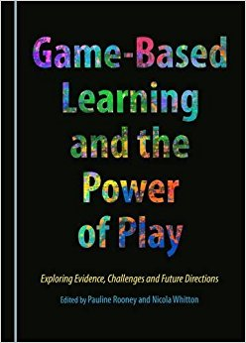
This book is an invitation to delve into the world of Game-Based Learning, to understand the many facets that make games a truly interesting and effective tool to teach and train in the 21st century. It includes nine chapters which were initially presented at the iGBL conference, a conference held throughout Ireland, where researchers, practitioners, students and other stakeholders meet and share their interest in games and education.
http://www.cambridgescholars.com/game-based-learning-and-the-power-of-play

Walsh, T. (2016). 100 years of primary curriculum development and implementation in Ireland: A tale of a swinging pendulum. Irish Educational Studies, 35(1), 1-16. DOI: 10.1080/03323315.2016.1147975.
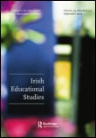
There are ongoing initiatives in curriculum development and implementation in Ireland and internationally in order to enhance the educational experiences and outcomes of learners. This article is the first historical longitudinal analysis of primary school curriculum development and implementation in Ireland from the 1890s to the 1990s. The purpose of the paper is to distil key lessons from the history of curriculum development and implementation to inform contemporary policy and practice. The paper begins by situating current curriculum discourse and developments in both a national and international context. It then delineates the three main curriculum reforms undertaken in Ireland in the period under review. The section relating to each period includes an overview of the societal context in which the curriculum was developed, the process of development, the content of each curriculum and its implementation. Three key themes emerge from the analysis - the impact of wider societal factors on curriculum, the impact of the radical nature of curriculum change attempted and a lack of focus on planning for implementation.

Walsh, T. (2016). The National System of Education 1831-2000 (in) Walsh, B. (2016)) (Ed.). Essays in the History of Irish Education. UK: Palgrave MacMillan, pp. 7-43.
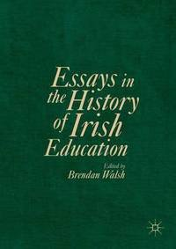
This chapter critically examines the establishment and development of the national system of education in Ireland between 1831 and 2000. The rationale for the establishment of the system is delineated at the outset. This is followed by an overview of the impact of wider contextual developments, including political, socio-economic, cultural and religious factors. The curricula developed and implemented in national schools during five distinct eras throughout the period is used as the armature around which the wider educational developments at primary level are structured. By focusing on what was taught, why it was taught and how it was taught, the chapter provides an insight into the evolving educational experiences of children in national schools in Ireland during the period. These curriculum eras are largely distinct by virtue of their context, the philosophy underpinning the curriculum, the content and methodologies advocated, the approach to teacher education and the concept of the child inherent in the curriculum. The five distinct periods are:
- The establishment of the national system [1831-72]
- The era of Payment by Results [1872-1900]
- The Revised Programme of Instruction (1900) [1900-22]
- The curricula developed following Independence [1922-71]
- The Primary School Curriculum (1971) [1971-99]
The chapter concludes by focusing on the key ideological changes underpinning the national system from its establishment in 1831.
McDaid, R. and Walsh, T. (2016). Challenging the Homogeneity of the Elementary School Teaching Force in Ireland (in) Schmidt, C. and Schneider, J (Eds.). Diversifying the Teaching Force in Transnational Contexts: Critical Perspectives. Rotterdam: Sense Publishers, pp. 153-164.
This chapter situates an examination of the contemporary experiences of Immigrant Internationally Educated Teachers (IIET) seeking to work in elementary schools in Ireland within a broader history of teacher selection and authorisation for that system. Empirical data generated through semi-structured interviews with IIETs reveal significant systemic barriers to their full recognition as elementary school teachers, with assessment of competency in the Irish language being a particularly acute obstacle. Tracing the historical trajectory of the Irish language requirements for entry to elementary teaching provides a rich context for comprehending the present situation.

The chapter is divided into two distinct sections. Firstly, the contemporary context and experience of IIETs is delineated. The second section examines the evolution of the selection and training of teachers from the advent of political independence in Ireland in 1922. The chapter concludes with some reflections on the contemporary position, and suggests some creative solutions to provide for a more heterogeneous elementary teaching force in Ireland.
Walsh, T. (2016). Recent Policy Developments in Early Childhood Education (ECE): A Jigsaw with too many pieces? (in) Murphy, R., Radley, P. and Ridgway, A. (Eds.) (2016). An Leanbh Óg, 10 :69-94.
In recent years, there have been a myriad of policy and practice developments in the field of early childhood education (ECE). These developments emanate from a range of government departments and agencies, including the Department of Children and Youth Affairs (DCYA), the Department of Education and Skills (DES), and the Child and Family Agency (TUSLA). This paper examines recent key policy developments and profiles the government departments and agencies responsible for their development and implementation. One of the key conclusions is that a clearer vision is needed for the sector to ensure that policies are coherent, consistent and manageable for those with a responsibility for their enactment.

Walsh, T. (2016). The Primary School Curriculum in Ireland: Looking at the Past - Learning for the Future (in) Mooney, B. (Ed.). Education Matters Yearbook 2016-17. Dublin: Education Matters, pp. 160-163.

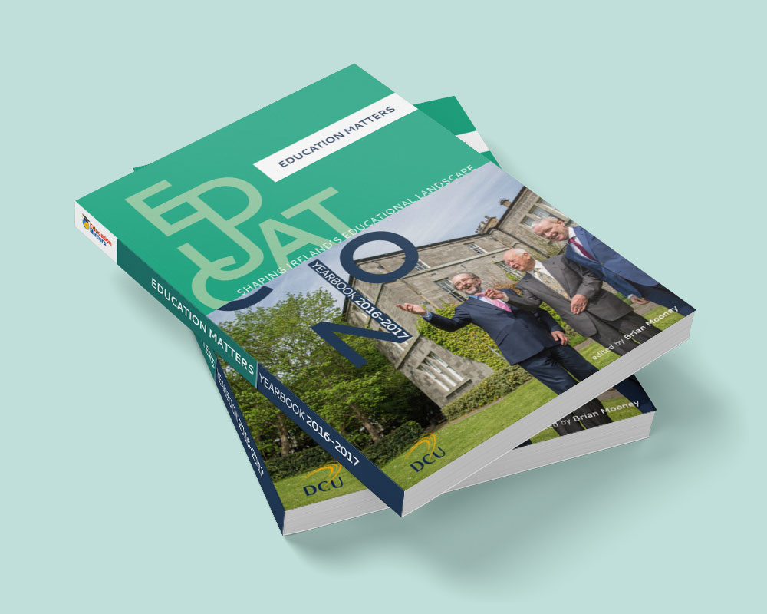

2016, the centenary year of the 1916 Rising which was a fundamental milestone in the quest for Irish Independence, has proven an apt year for reflection on the past. It is in this reflection that we find many resonances between past and present as we negotiate and plan for the future. This is indeed true of the education system, and particularly the primary school curriculum, which has been shaped and reshaped by many over the past 100 years. This article reflects on the key milestones in curriculum development since the start of the twentieth century, examines the context and rationale for these developments, analyses what was considered important for young children to learn at various junctures, and the success or lack thereof in the implementation of curriculum policy. Four key eras of curriculum policy are examined:
- The Revised Programme of Instruction introduced in 1900
- The curricula introduced in the 1920s following Independence
- The Primary School Curriculum (1971)
- The Primary School Curriculum (1999)

Walsh, T. (2016) Early Childhood Care and Education in Ireland 2016 (in) Mooney, B. (Ed.). Education Matters Yearbook 2016-17. Dublin: Education Matters, 107-112.

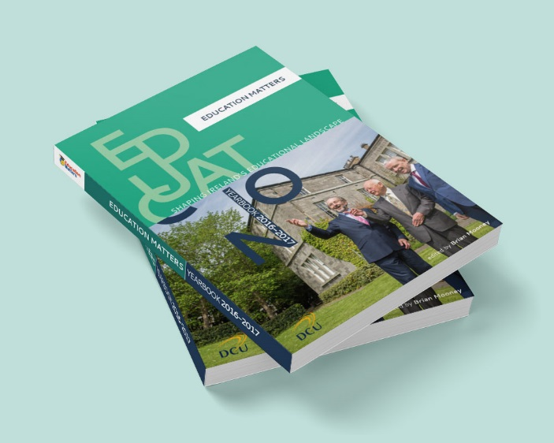
The year 2016 was indeed a busy one in the early childhood care and education (ECCE) sector. It was a year during which many policy initiatives mooted for a number of years came to fruition and began to impact on early childhood educators. One catalyst for this activity was the provision of an additional €85 million in funding for the ECCE sector in budget 2016 which enabled the roll out of many new initiatives for the sector. This necessary increased investment will need to be sustained into the future to support the evolving role and continued vibrancy of the ECCE sector. While an increased focus on and funding for the sector is welcome, one concern is the challenge of managing and supporting change in a sector that has grown exponentially in recent years. Much of this change has added to the complexity of the role undertaken by early childhood educators, in particular in the interface between individual settings and new state initiatives (Walsh, 2016).
While there was a number of important broad developments in ECCE in 2016, this chapter will focus on four key developments in the sector, as follows:
- The expansion of the ECCE Programme from September 2016
- The initiation of education-focused early childhood inspections
- The publication of the revised regulations for pre-schools in May 2016
- The initiation of the Access and Inclusion Model (AIM) for children with special educational needs

