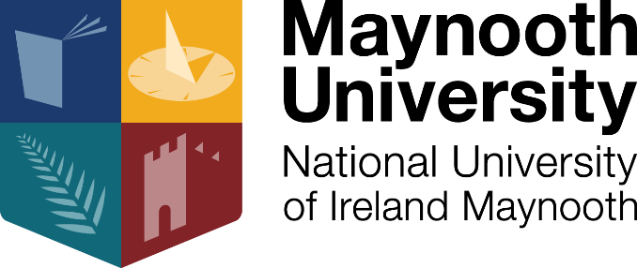

School of Business
Industry Speaker Series 2017-2018

‘Highlights of International Business’

Date: Wednesday, 25th April 2018
Time: 12.00pm
Venue: Rye Hall Lecture Theatre, (North Campus)

About the Event
We are delighted to announce the next event in the School of Business’ Industry Speaker Series, which will have an exciting panel discussion on ‘Highlights of International Business’. The event will feature speakers from The Sport, Manufacturing and Pharmaceutical sectors

We will have experts in the field from United Drug, Fortem Building Materials and Leo Nulty Promotions.

The panel will discuss:
- Changes and challenges of international business
- Career opportunities in international business
- Securing international clients

Get ahead of the competition and secure your place now at what promises to be a very informative career event!

To RSVP, please email business@mu.ie.

