Maynooth Green Campus - Report to the Faculties March 2019

Our structure
The organigram below shows the way Maynooth Green Campus makes links with this basic structure or organisation and allows for the facilitation of a wide range of initiatives and depends on the “buy-in” of key units on the campus, of faculty and all staff, and students. Keep up the good work everybody. Keep the Flag flying!

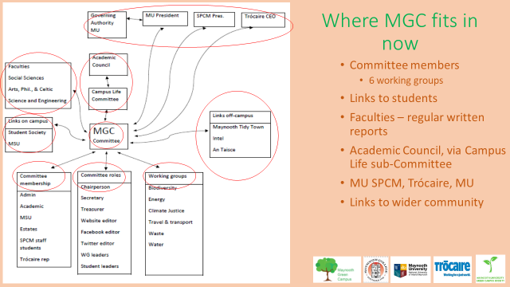Future plans
The chair of Green campus met the President of Maynooth to discuss proposals for taking forward the work of Green Campus in the next phase, following the achievement of the Green Campus flag across all of An Taisce’s themes (Energy, waste, water, Travel & Transport, biodiversity) plus one (Climate Justice), which we introduced to the programme. We are now in a position to step-up the place of sustainability on campus and the strengthen the role of the University in providing leadership on climate justice, and in the other areas. The proposals are being actively considered.

National Green Campus Network Annual meeting – Radisson Hotel – 7th February
The chair of MGC gave a presentation on how the committee has worked. He presented an organigram showing the various mechanisms used to promote awareness across the six themes for which we received the Green Flag in 2018. Most other colleges have won the flag for one or a few of the themes. There was a very positive response to the presentation and the Maynooth model of working that we have developed. This model comprises a partnership built on citizenship and systems on campus, with a range of cross-sectoral co-operative arrangements to address various challenges, and it has worked very well. This model is illustrated in an organigram included in the MGC presentation to the Network meeting.

RCSI visit
We have been approached by others to offer advice since the network meeting and there will be a delegation from the RCSI shortly to meet with us and discuss our experience and approach. A number of representatives from Maynooth campus attended the meeting. Slides from the different contributors at the meeting Slides presented at the network meeting by various contributors are available. Further information from greencampus@mu.ie

MU Environmental Society (MU Envirosoc)
The Envirosoc organised a Green Careers session with Niall Sargent Niall Sargent, who is Communications and Development Officer at the Irish Environmental Network and editor of The Green News. IEN links up Irish Environmental NGOs across a range of environmental issues from wildlife conservation to climate change. Contact mireia.guardinoferran.2016@mumail.ie

Biodiversity working group
1. There will be a campus walk and talk during National Tree Week in conjunction with Maynooth Tidy Towns (31st March - 7th April- date & time to be confirmed).
2. The Biology dept./Biodiversity working group are hosting a National Biodiversity Data Centre workshop (Gardening for wildlife) on 13th April in conjunction with Wild Kildare.
Further information from Abigail.maher@mu.ie

Food Sovereignty

Maynooth University’s Festival of Food Sovereignty, April 9th, 2019
10am to 1pm: Workshop I “Collective sustainability through community gardens and farms”, led by Nathan Jackson, Celbridge Community Supported Agriculture: Room SE014, School of Education Building, North Campus, Maynooth University

2.30 to 4.30pm: Workshop II “Building and sustaining community land trusts and community supported farms: The Kulturland experience” With critical insights from Thomas Rippel, Project Manager, Kulturland, Germany: John Hume Building, Lecture Hall 6 (first floor), North Campus, Maynooth University

5pm: Public Lecture “Our food system: climate change and the need for transformation” Judith Hitchman, President of Urgenci, France: John Hume Building, Lecture Hall 2 (ground floor), North Campus, Maynooth University
- Music on the day from Imogen Gunner & friends.
- Lunch provided for registered attendees. Space limited.
- Register at: https://www.eventbrite.ie/e/maynooth-universitys-festival-of-food-sovereignty-tickets-57395059167
Further information: Alistair.Fraser@mu.ie

Fair Trade coffee & Reusable Cups
Michael Rafter, Campus services, has led work to renew our Fairtrade accreditation, which had lapsed. The price of Fairtrade coffee is higher than other brands. Therefore, in conjunction with introducing Fair Coffee across the Campus, it is proposed that the price of beverages purchased on campus would increase, except if the purchaser uses a re-usable cup. In effect, there will be a supplement of 30 cent on beverages served in single-use cups. This supplement will also apply to compostable cups, which are single use, albeit bio-degradable. Campus services have made it possible to measure the use of re-usable cups on campus at the checkouts. Further information Michael.rafter@mu.ie

Climate Justice
In late January There was a Meeting of climate justice working group with representatives (2) from SPCM, Trócaire (3) and Maynooth University (2) to consider ideas for the coming period. A further meeting will take place soon. We invite suggestions from staff and students on this subject. Further information Joe.larragy@mu.ie

MGC committee meeting
23 January 2019: Considered reports on progress with estates, student activity, climate justice work. Reviewed the priority work to be done on communications. Susan Giblin has joined this working group and its work should be front and centre in 2019. Contact greencampus@mu.ie

Social Justice Week
Green Campus were active in the events of Social Justice Week. Climate Justice and the challenge of a “just transition” to the post-carbon economy featured in a roundtable on 7th March that included researchers from ICARUS, the Jesuit Centre for Faith and Justice, Trócaire, MGC, Envirosoc and others, in the company of several groups of students. Contact greencampus@mu.ie
Froebel Staff organised a number of environment-related and climate-justice events and made a particular effort to relate to the upsurge in consciousness among school children and the climate strikes (especially forthcoming one on 15th March). Contact Aoife.titley@mu.ie

