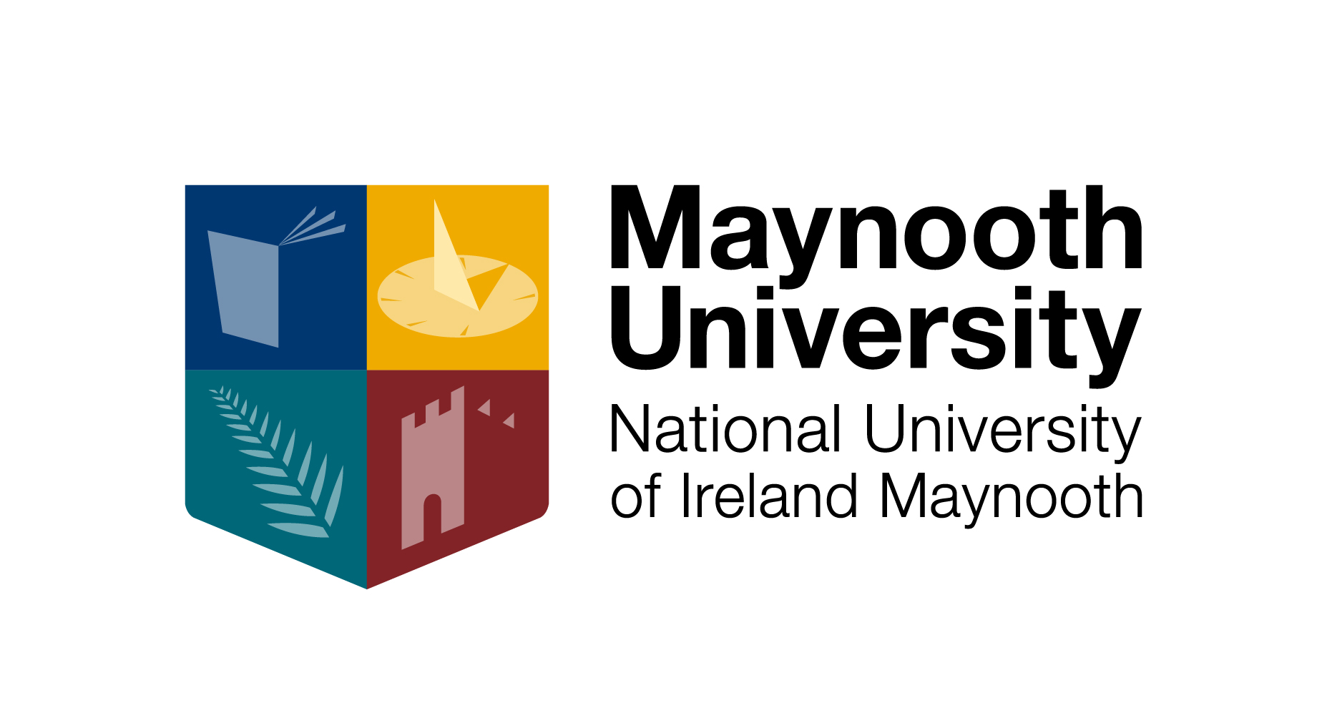

McCann Fitzgerald

Postgraduate Scholarship

2016-17

Application Form

Please ensure you have read the ‘McCann FitzGerald Postgraduate Scholarship Terms & Conditions’ before completing this application form. Please complete in block capitals or typescript. Applicant should submit personal CV in addition to this application form.

All fields are mandatory

1. Applicant Details:

FULL NAME:

MAILING ADDRESS:

TELEPHONE:

EMAIL:

MAYNOOTH UNIVERSITY DEPARTMENT:

ARE YOU/HAVE YOU BEEN A MAYNOOTH UNIVERSITY STUDENT?

YES / NO (delete as applicable)
IF ‘YES’, PLEASE PROVIDE STUDENT NUMBER:

2. Proposed Programme of Study

PROPOSED COURSE OF STUDY:

Masters Degree in Mediation and Conflict Intervention (1yr F/T)

THE PAC NUMBER OF YOUR APPLICATION TO THE ABOVE PROGRAMME: (required if you are a new applicant 2016)

3.PERSONAL STATEMENT Please outline in 300 words or less why you are applying for this scholarship and your personal interest in the subject area.

3. THESIS PROPOSALPlease outline in 1,000 words or less how your proposed Masters dissertation aligns with the key themes of the Mediation Scholarship Award. (Please see terms and conditions 2016 for guidance)

4. Third level education:
If you are not a current/past graduate of Maynooth University, please include your primary honours undergraduate overall degree result e.g. 2.1 etc. and attach your final transcripts. Please note a minimum 59.1% overall or 2.1 result is required. If you are a final year student, please include your previous results.

Name of Institution | Dates Registered | Title of programme | Subjects studied | Overall grade obtained | Date of Examination Results

5. Declaration:

I confirm that the information given is correct. I also confirm that I have read and understood the Terms and Conditions associated with this award scheme.

Signature: ______________________ Date: ___________________

Completed application form and attached CV should be submitted to the Graduate Studies Office, 3rd Floor John Hume Building, Maynooth University, Maynooth, Co. Kildare
postgraduatescholarships@nuim.ie by the 31st March 2016

