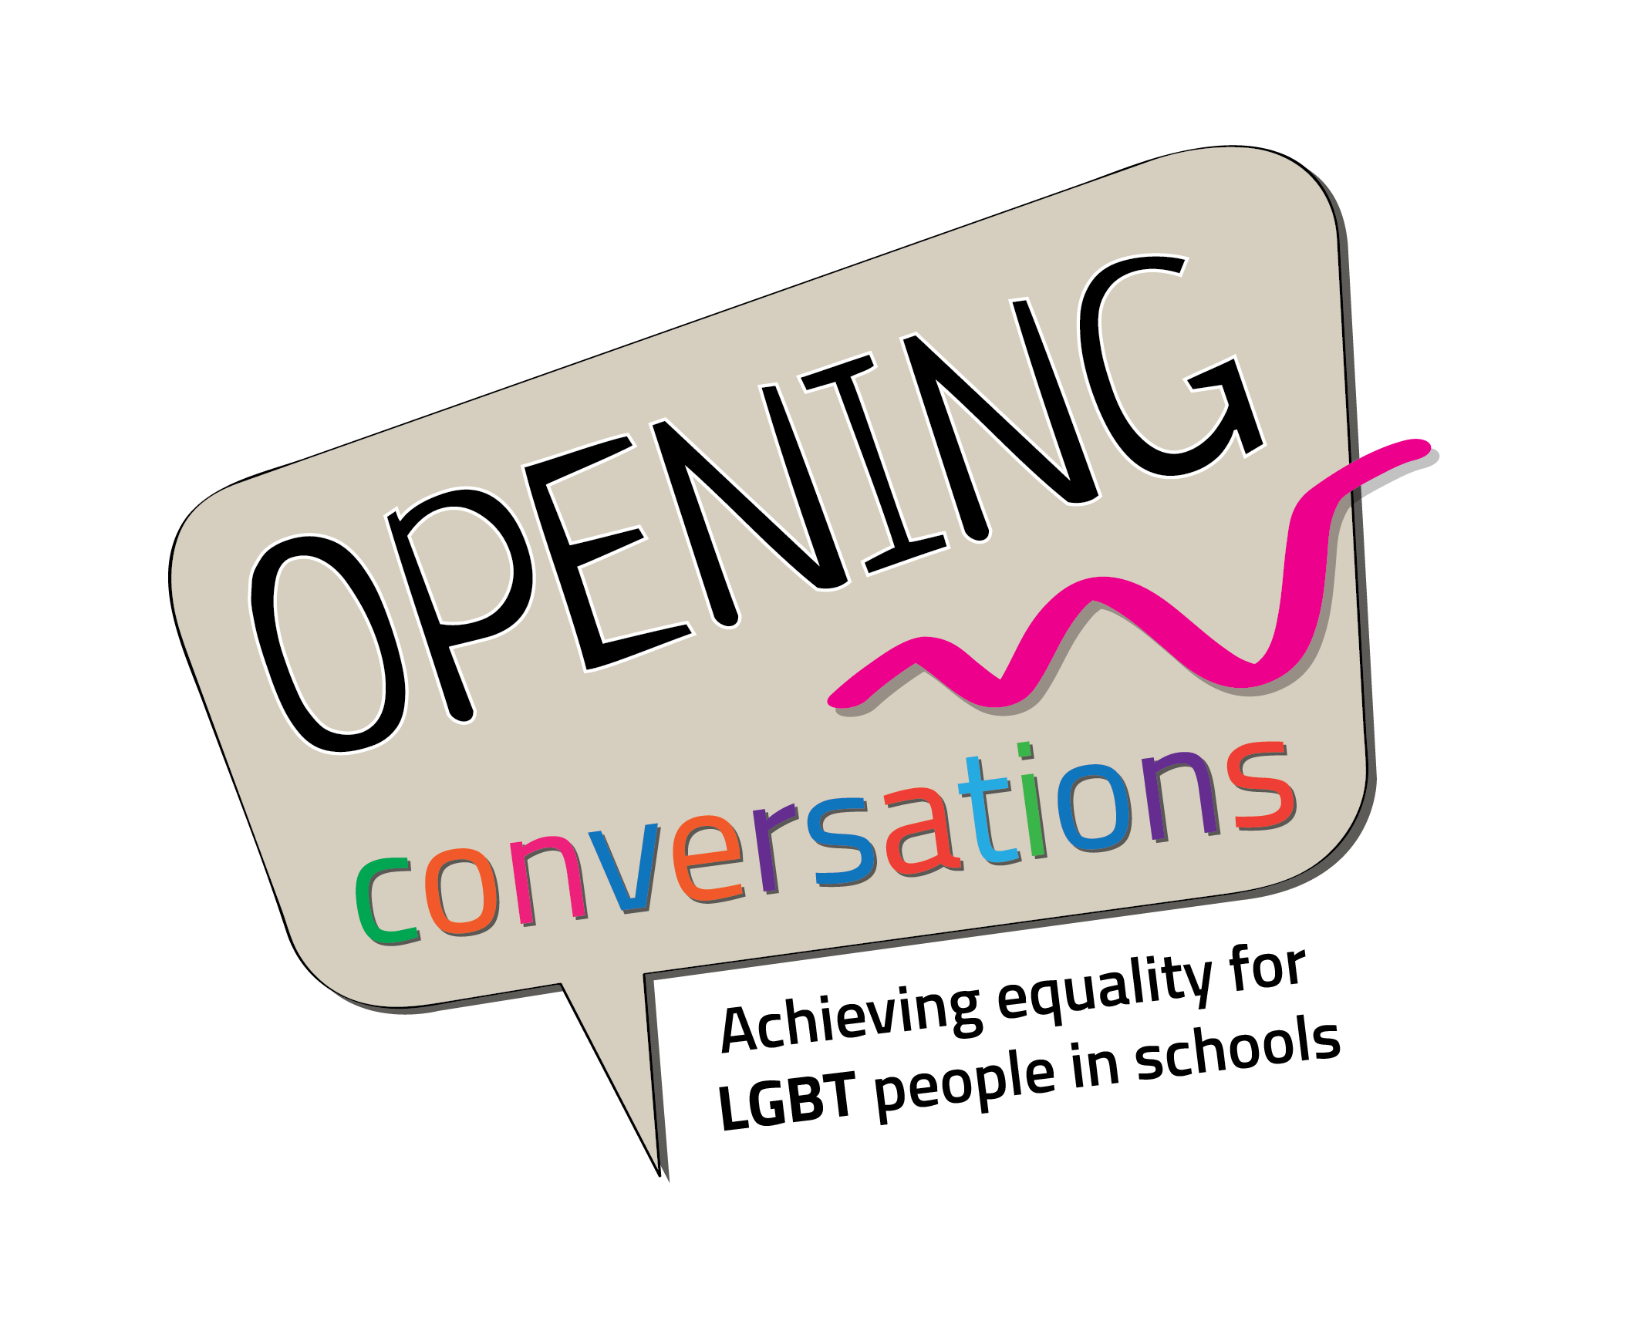 |  | Department of Education  Maynooth University  Iontas Building  North Campus  Friday 29th January 2016  @MU_Education #ocLGBT
8:30-9:10 | Registration: Iontas Foyer
9:10-9:45 | Welcome and Launch  Prof Philip Nolan, President of Maynooth University and Prof Sharon Todd, Head of Maynooth University Department of Education  Guest speaker: John Lyons, TD
9:45-11:00 | Opening Conversation  Facilitator: Angela Rickard (MU)  Panelists: Dr Fergus Ryan (MU), Sandra Irwin-Gowran (GLEN), Dr Gráinne Healy
11:00-11:30 | Tea/Coffee Break: Iontas Foyer
11:30-13:00 | Creative Conversations  Details page 2
13:00-14:00 | Lunch
14:00-15:00 | Policy into Practice Conversations  Details page 3
15:00-15:45 | Keeping the Conversation Open  Facilitator: Prof Sharon Todd  Panelists: Danny Tynan, Sam Blanckensee, Dr Mary Gannon, Other TBC
15:45-16:00 | Tea/Coffee Break: Iontas Foyer
16:00-16:45 | Staged reading  Citizenship by Mark Ravenhill, performed by Kildare Youth Theatre, as part of the National Theatre of Britain's Connections 500 programme.

11:30-13:00 - Parallel Workshops I: Creative Conversations
Arts-based, creative workshops that showcase innovative projects/ideas and professional development for teachers engaging with themes of sexuality, identity and gender in schools.

SESSION 1  Nicole Rourke and Nathan O’Donnell, Big Smoke Writing Factory | Away with Words: Exploring personal expression through creative writing  ‘We don't stop playing because we grow old; we grow old because we stop playing’.  - George Bernard Shaw  This workshop aims to ignite your creativity in an inspiring and enjoyable way. The session will be led by Nicole Rourke, workshop facilitator/performer and Co-Director of Big Smoke Writing Factory. No experience necessary! www.bigsmokewritingfactory.com
SESSION 2  Peter Hussey and Kildare Youth Theatre | Performances from Nothing  Very often we find ourselves searching for stimulating material to use with young people to help them create stories and performance material that will have substance and meaning. At other times we search for the perfect script to challenge the class and provide roles for everyone. This workshop asks us to begin with nothing but ourselves, and to pay attention to what we see, and from that to structure performance material to shape into engaging and truthful pieces of documentary theatre.
SESSION 3  Debbie Thomas (Writer) | Inside Story ‘Stories are equipment for living.’ - Kenneth Burke  We read them, watch them, tell and dream them. From cave paintings to crime fiction, stories have always connected, comforted and challenged human beings. This creative writing workshop explores how stories can help us grow in compassion, find common ground and express our own truths born of experience. www.debbie-thomas.com
SESSION 4  Eóin Houlihan, Teacher with TY students from Moyle Park, Clondalkin | This Lesson is So Gay!: Student-led LGBT awareness initiative by Moyle Park TY students  Our LGBT lesson plan is focused on explaining to first years what LGBT stands for. We also want students to think about what life can be like for an LGBT person. We do this through a series of discussions and exercises. Ultimately being gay is okay!
SESSION 5  Seán Henry (MU) with students from Mount Temple Comprehensive School Malahide Rd., Dublin. | Hearing Our Voices: Students’ Experiences of Achieving LGBT Equality at School  Students from SPECTRUM, the LGBT support group at Mount Temple will share their stories of coming out as LGBT at school, their experiences of being part of SPECTRUM and the challenges and opportunities they face in school on a daily basis.
SESSION 6  Michelle Stowe, Teacher and RP practitioner | At the Heart of Inclusion: Restorative Practice (RP)  This workshop will briefly outline the philosophy, motivation and skills to use RP. The intention is to offer an insight into how restorative practices and values can open up new capacities of mind and heart; facilitate conversations that promote inclusion, connection and care in school communities
SESSION 7  John Ruddy, Youth worker with Dundalk Outcomers Youth Group | Guardians of the Galaxy: how Inclusion begins and ends with teachers  This introductory professional development workshop for teachers combines personal reflection and professional application. It explores how teachers can inhabit an inclusive space in schools with honestly and open-heartedness for the benefit of all members of the school community.

14:00-15:00 - Parallel Workshops II: Policy into Practice Conversations

One hour sessions to provide insights and practical advice to teachers, teacher educators, guidance counsellors, school leaders and other educators seeking to develop and sustain inclusive policies and practices in schools and colleges.

SESSION 1 | Creating an open, positive and safe school environment for LGBT students in a second level setting  Facilitator/s: Vickie Stokes (teacher of French, Geography, SPHE & Lifeskills) Kelly McGrath (teacher of Spanish & SPHE) from Castleknock Community School with Karen Farrell (parent)
SESSION 2 | Stimulating conversation in the classroom  Facilitator/s: Karen O’Shea/ Dr Mary Gannon (Uaisleacht)
SESSION 3 | Queering the discourse: negotiating sexual identity in Iniital Teacher Education  Facilitator/s: Dr Declan Fahie
SESSION 4 | Supporting teachers supporting students: the role of the unions  Facilitator/s: Diarmaid de Paor, Deputy General Secretary, ASTI; Others TBC
SESSION 5 | Gender and Sexuality Diversity: The Perspectives of School Leaders, Managers and Trustees  Panelists: Dee Mangaoang (Educate Together); Clive Byrne (NAPD/ESHA); Máirín Ní Chéileachair (Gaelscoileanna); Dr Michael Redmond (JMB), Gerry Bennett, Dr Marie Griffin (Association of Trustees of Catholic Schools)
SESSION 6 | The politics of care: understanding the silencing effects of school culture on voice. Guidance counsellors share their experiences of supporting LGBT students in schools.  Facilitator/s: Dr Grace O’Grady  Panelists: Betty McLoughlin (President IGC), Brian Mooney (former President IGC and Irish Times columnist) and Arthur Dunne (former President IGC and lecturer in Maynooth Univeristy Department of Education)

