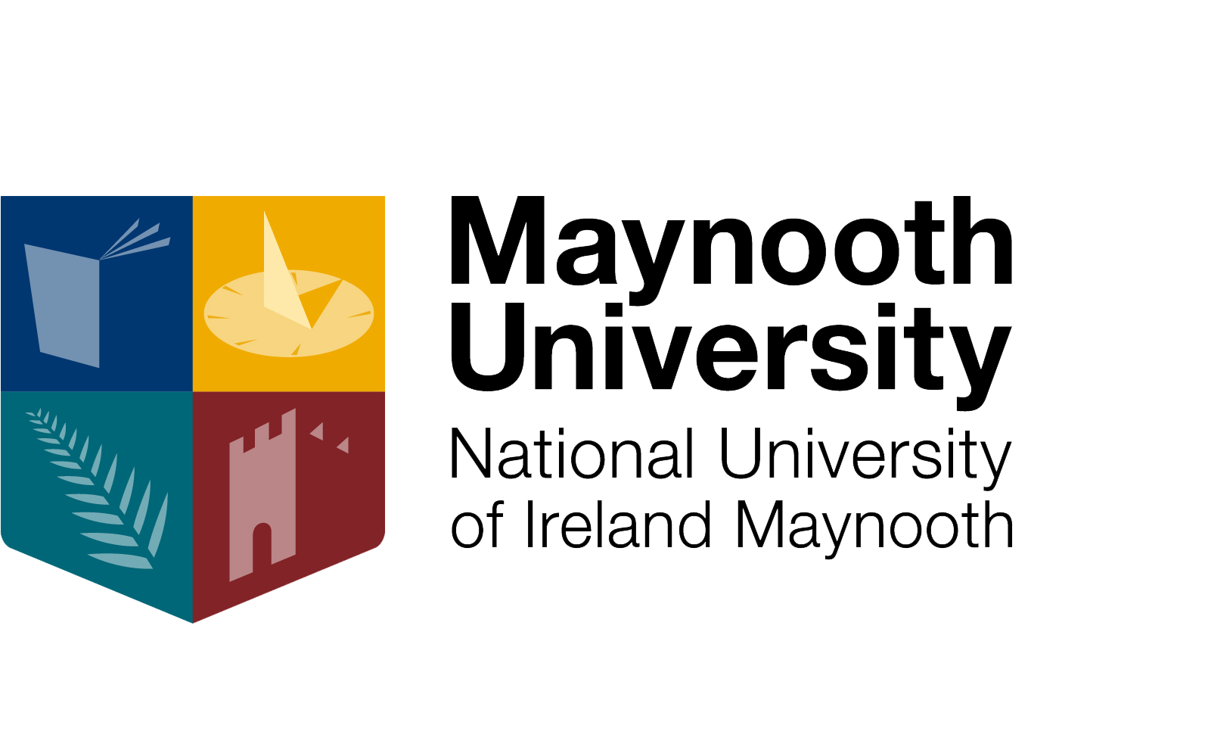

ROINN NA MATAMAITICE AGUS NA STAITISTICE

DEPARTMENT OF MATHEMATICS & STATISTICS

POSTGRADUATE

HANDBOOK

2024/2025

Ollscoil na hÉireann, Má Nuad, Co. Chill Dara, Éire.

©2024 National University of Ireland, Maynooth, Co. Kildare, Ireland.
All rights reserved.

Contents
ABOUT THE DEPARTMENT OF MATHEMATICS & STATISTICS 3
DEPARTMENT STAFF 4
POSTGRADUATE COORDINATORS 6
RESEARCH INTERESTS OF STAFF 7
INTRODUCTION TO POSTGRADUATE COURSES 8
ERASMUS PROGRAMME 9
SCHOLASTIC FUNDING 10
RESEARCH STUDENT SUPERVISORY POLICIES 10
HOW TO APPLY FOR A POSTGRADUATE COURSE AT MAYNOOTH UNIVERSITY 11

EDI TRAINING………………………………………………………………………………………………………………………12

ABOUT THE DEPARTMENT OF MATHEMATICS & STATISTICS

Welcome to the Maynooth University Department of Mathematics and Statistics. We are normally located in Logic House at the southern end of the old Campus. We hope you find this handbook of some help to you. If you have any further enquiries, please email mathsstats@mu.ie.

OFFICE HOURS –

10.00 a.m. - 11.00 a.m.
12.00 p.m. - 1.00 p.m.
2.00 p.m. - 4.00 p.m.

E-mail: mathsstats@mu.ie

Website: https://www.maynoothuniversity.ie/mathematics-and-statistics

The information in this handbook is as accurate as we can make it at the time of going to press, but it may be in error. In the event of difference, the official University rules and procedures take precedence over anything in this handbook, and nothing in this handbook should be understood as official.

TERM DATES: 2024-2025
https://www.maynoothuniversity.ie/registrar/key-term-dates

FIRST SEMESTER
Orientation Week | 16th September 2024 | 20th September 2024
First Semester | 23rd September 2024 | 20th December 2024
Study Week | 28th October 2024 | 1st November 2024
Christmas Break | 23rd December 2024 | 3rd January 2025
Study Period | 6th January 2025 | 11th January 2025

SECOND SEMESTER
Second Semester | 4th February 2025 | 9th May 2025
Study Week | 17th March 2025 | 21st March 2025
Easter Vacation | 21st April 2025 | 25th April 2025
Study Period | 13th May 2025 | 16th May 2025

DEPARTMENT STAFF

Professor Stephen Buckley, Head of Department
https://www.maynoothuniversity.ie/mathematics-and-statistics/our-people/stephen-buckley

*****************************************************************

Dr Niamh Cahill, Lecturer
https://www.maynoothuniversity.ie/mathematics-and-statistics/our-people/niamh-cahill

Dr Galatia Cleanthous, Lecturer
https://www.maynoothuniversity.ie/mathematics-and-statistics/our-people/galatia-cleanthous

Dr Rafael de Andrade Moral, Senior Lecturer
https://www.maynoothuniversity.ie/mathematics-and-statistics/our-people/rafael-de-andrade-moral

Dr Detta Dickinson, Senior Lecturer
https://www.maynoothuniversity.ie/mathematics-and-statistics/our-people/detta-dickinson

Dr Katarina Domijan, Lecturer
https://www.maynoothuniversity.ie/mathematics-and-statistics/our-people/katarina-domijan

Dr Catherine Hurley, Senior Lecturer
https://www.maynoothuniversity.ie/mathematics-and-statistics/our-people/catherine-hurley

Dr Christian Ketterer, Lecturer
https://www.maynoothuniversity.ie/people/christian-ketterer

Dr Ciarán Mac an Bhaird, Senior Lecturer
Director, Mathematics Support Centre
https://www.maynoothuniversity.ie/mathematics-and-statistics/our-people/ciar-n-mac-bhaird

Professor David Malone
https://www.maynoothuniversity.ie/mathematics-and-statistics/our-people/david-malone

Professor Oliver Mason
https://www.maynoothuniversity.ie/mathematics-and-statistics/our-people/oliver-mason

Dr Keefe Murphy, Lecturer
https://www.maynoothuniversity.ie/mathematics-and-statistics/our-people/keefe-murphy

Dr John Murray, Senior Lecturer
https://www.maynoothuniversity.ie/mathematics-and-statistics/our-people/john-murray

Dr Fiacre Ó Cairbre, Senior Lecturer
https://www.maynoothuniversity.ie/mathematics-and-statistics/our-people/fiacre-cairbre

Dr Eoin O’Brien
https://www.maynoothuniversity.ie/faculty-science-engineering/our-people/eoin-obrien-0

Professor Ann O’Shea
https://www.maynoothuniversity.ie/mathematics-and-statistics/our-people/ann-oshea

Professor Andrew Parnell
https://www.maynoothuniversity.ie/mathematics-and-statistics/our-people/andrew-parnell

Dr Lars Pforte
https://www.maynoothuniversity.ie/faculty-science-engineering/our-people/lars-pforte

Dr Mark Walsh, Lecturer
https://www.maynoothuniversity.ie/mathematics-and-statistics/our-people/mark-walsh

Professor David Wraith
https://www.maynoothuniversity.ie/mathematics-and-statistics/our-people/david-wraith

SUPPORT STAFF
Mr Stephen Fagan, Executive Assistant
https://www.maynoothuniversity.ie/people/stephen-fagan

Ms. Janice Love, Senior Technical Officer
https://www.maynoothuniversity.ie/mathematics-and-statistics/our-people/janice-love

Ms. Gráinne O’Rourke, Administrator
(Tel: 01 – 7083914/3651)
https://www.maynoothuniversity.ie/mathematics-and-statistics/our-people/gr-inne-orourke

Mr. Anthony Waldron, Technical Officer
https://www.maynoothuniversity.ie/mathematics-and-statistics/our-people/anthony-waldron

POSTGRADUATE COORDINATORS

MATHEMATICS 2024/-25

Dr Mark Walsh
https://www.maynoothuniversity.ie/mathematics-and-statistics/our-people/mark-walsh

HIGHER DIPLOMA IN DATA ANALYTICS 2024/-25

Dr Keefe Murphy, Lecturer
https://www.maynoothuniversity.ie/mathematics-and-statistics/our-people/keefe-murphy

MASTERS IN DATA SCIENCE AND ANALYTICS 2024/-25

Dr Katarina Domijan
https://www.maynoothuniversity.ie/faculty-science-engineering/our-people/katarina-domijan

PhD in STATISTICS 2024/-25

Dr Catherine Hurley
https://www.maynoothuniversity.ie/mathematics-and-statistics/our-people/catherine-hurley

RESEARCH INTERESTS OF STAFF

For the most accurate and up-to-date information, please go to the department website

https://www.maynoothuniversity.ie/mathematics-and-statistics/our-people

INTRODUCTION TO POSTGRADUATE COURSES

The Mathematics & Statistics Department offers postgraduate students the opportunity to study Mathematics or Statistics for the degrees of PhD, MSc, MA, or for a Higher Diploma in Mathematical Studies, Mathematics and Statistics, Data Analytics, or a Masters in Data Science & Analytics.
Please note that all postgraduate Mathematics and Statistics courses can be taken on a part-time basis over two or more years. Students who study on a part-time basis attend the regular daytime classes. The Department does not offer any classes during the evening or at weekends.

Information on Fees can be found on the University website at:
https://www.maynoothuniversity.ie/student-fees-grants

HIGHER DIPLOMA IN MATHEMATICAL STUDIES
https://www.maynoothuniversity.ie/study-maynooth/postgraduate-studies/courses/higher-diploma-mathematical-studies

HIGHER DIPLOMA IN MATHEMATICS
https://www.maynoothuniversity.ie/study-maynooth/postgraduate-studies/courses/higher-diploma-mathematics

HIGHER DIPLOMA IN STATISTICS
https://www.maynoothuniversity.ie/study-maynooth/postgraduate-studies/courses/higher-diploma-statistics

HIGHER DIPLOMA IN DATA ANALYTICS
https://www.maynoothuniversity.ie/study-maynooth/postgraduate-studies/courses/higher-diploma-data-analytics

MSc in MATHEMATICS OR STATISTICS BY RESEARCH
https://www.maynoothuniversity.ie/study-maynooth/postgraduate-studies/courses/msc-mathematics

MSc in MATHEMATICS BY EXAMINATION
https://www.maynoothuniversity.ie/study-maynooth/postgraduate-studies/courses/msc-mathematics-0
MASTER IN DATA SCIENCE AND ANALYTICS

https://www.maynoothuniversity.ie/study-maynooth/postgraduate-studies/courses/msc-data-science-and-analytics

PhD IN MATHEMATICS
https://www.maynoothuniversity.ie/study-maynooth/postgraduate-studies/courses/phd-mathematics

PhD IN STATISTICS
https://www.maynoothuniversity.ie/study-maynooth/postgraduate-studies/courses/phd-statistics

ERASMUS PROGRAMME

The Department has exchange agreements under the ERASMUS programme with a number of European universities. Students may spend up to half of one year at another university under this program, provided that a suitable programme of studies is arranged. For the Masters degree by examination, certain courses offered at the Universities of Kiel, Tübingen, Ulm (Germany), and the University of La Laguna (Tenerife) have been approved by the NUI as suitable to form part of the Maynooth course. You can find some useful links at
https://www.maynoothuniversity.ie/international

SCHOLASTIC FUNDING

There are opportunities for talented postgraduate students to get funding at Maynooth University, in either taught or research-based courses. Depending on the nature of the award, this can range from funding to cover fees, up to a full scholarship with not only fees, but a living allowance and provision for expenses also.
Competition for both Maynooth University funding and funding from other agencies is very high.
Further information can be found on the Maynooth University website at:
https://www.maynoothuniversity.ie/study-maynooth/postgraduate-studies/fees-funding-scholarships

RESEARCH STUDENT SUPERVISORY POLICIES

For information about the University’s research student policies, contact Marie Murphy of the Graduate Studies Office (marie.murphy@mu.ie).
Students doing research degrees should also read the Mathematics & Statistics Department Research Student Policy Document:
https://maynoothuniversity.ie/sites/default/files/assets/document//policy_res_student_2022.pdf
Structured Research students must take a certain number of taught modules, as explained in the above policy document. Other research students can also avail of these modules. The most relevant modules are the 800 level modules on the following webpage, although 500-level and other modules can also be taken with the permission of the Head of Department:
https://www.maynoothuniversity.ie/mathematics-and-statistics/undergraduates/module-descriptors-202425

HOW TO APPLY FOR A POSTGRADUATE COURSE AT MAYNOOTH UNIVERSITY

TAUGHT POSTGRADUATE COURSES:
Before you submit an application, please discuss your choice of course with the relevant Department Postgraduate Coordinator (see the names of the coordinators above).

RESEARCH DEGREE:
Before submitting any application for a Research degree, please ensure you have the prior agreement of a research supervisor.
If you have satisfied the above criteria, you may proceed and submit your application to the:

POSTGRADUATE APPLICATIONS CENTRE
www.pac.ie/

EDI Training

EDI training is a potent tool for increasing awareness, enhancing comprehension, and equipping individuals with the skills required to both implement and advocate for fairness, respect, and the celebration of our differences. It empowers participants to cultivate inclusivity within their departments, thereby creating a university atmosphere that is welcoming and enriching for everyone.

How to Get Involved:
Participation in online EDI training initiatives is open to all students. We strongly encourage you to take advantage of these opportunities to enhance your understanding of EDI principles and practices, and to actively contribute to a more inclusive community.

The Equality Office has shared a helpful list of EDI-related online courses / training sessions at Maynooth University and highlighted who they are available to.

Training | Location | Staff / Students?
EDI in HE & Let’s Talk About Race | Moodle | Available to staff and students at MU
Consent at MU – Preventing Sexual Violence & Harassment | Moodle | Available to staff and students at MU
Sexual Health | Maynooth University (Student link)  Staff Courses | Maynooth University (Staff link) | Moodle | Available to staff and students at MU
Disability Awareness Training – National Disability Authority | Online | Open access
- Communicating Across Cultures Bitesize Course  - Dignity in the Workplace Bitesize Course  - Managing Diversity Bitesize Course  - Equality, Diversity & Inclusion Course online | DCM Learning Courses | Available to MU staff through Learning & Development

Completion of the online training is recommended to everyone. Please feel free to share any student accessible links with fellow students directly and encourage them to participate in these free online trainings.

We firmly believe that through education, understanding, and active engagement, we can collaboratively create a more inclusive and equitable environment for all members of our faculty and our students.

