Department of History

Second Year Special Topics - Semester 1

2024-25

[5 credits: two hours per week]

Students select one of the following modules in the first semester.

HY218 Ireland in the modern world: the nineteenth century
Dr Sarah Roddy

HY241 American history (B)
Dr JoAnne Mancini

HY294 Europe post 1945
Dr Raul Cârstocea

national university of ireland, maynooth
department of history
second arts, 2024-25

First Semester
Lecturer  DR SARAH RODDY | Module code HY 218 | Credits  5 | Lecture hours per week  Two

Module title
IRELAND IN THE MODERN WORLD: THE NINETEENTH CENTURY

This module is designed to provide students with a broad introduction to the major social, political, economic and cultural developments that impacted Irish life and society from the Act of Union in 1801 to the passing of the Wyndham Land Act in 1903. It examines key issues such as the struggle for Catholic Emancipation and Repeal; the causes and consequences of the Great Famine; the birth of the two political ideologies – nationalism and unionism – that defined so much of Irish life and politics in the late nineteenth and early twentieth centuries; the role of the land question; the rise of cultural nationalism; religious change; and changes for women resulting from the active campaigns of the first wave of feminists in Ireland. This course requires consistent reading of secondary source material and students should independently read a core textbook as well as the recommended supplementary reading to keep up with the course content. The Moodle page for this course contains vital resources that should be consulted regularly.

Objectives of HY218
At the end of this course students should have a broad understanding of modern Irish social, cultural, political and economic history, and an understanding of the major themes and issues that have shaped the two Irelands today. Students will be encouraged to read widely and to engage with historiographical debates and to develop an understanding of historical research and use of primary sources.

Learning Outcomes
Students should be able to demonstrate in their written work an understanding of the main factors shaping the history of modern Ireland in the nineteenth century. They should be able to analyse and critically assess secondary sources and present cogent, coherent arguments.

Form of assessment
Two-hour examination at end of semester (100% of total mark)
Module Structure:
This module will consist of 24 contact hours in the form of two-hour lectures.

Recommended core text: Alvin Jackson, Ireland 1798-1998: politics and war (2nd ed., Oxford, 2010).

national university of ireland, maynooth
department of history
second arts, 2024-25

First Semester
Lecturer  DR JOANNE MANCINI | Module code  HY 241 | Credits  5 | Lecture hours per week  Two

Module title

American History Special Topic (B)

Module Content
This is a broad survey module that looks at American history from the Civil War to the present. It will begin with a brief discussion of the outcomes of the Civil War, and then take a generally chronological approach, considering key periods of transformation such as Reconstruction, the Great Depression, and the Civil Rights Era. Along the way, the module will also address thematic issues in political, social, economic, and cultural history such as industrialisation, immigration, empire, and social and cultural change. The module also aims to introduce students to electronic resources for the study of American history, including primary source documents and repositories.

Students will be required to complete a range of assigned readings throughout the module, to include journal articles and primary sources.

Aim
To teach an understanding of the history of the United States from the Civil War to the present.

Module Structure:
This module will consist of 24 contact hours in the form of two-hour lectures.

Form of assessment:
Two-hour examination at end of semester

national university of ireland, maynooth
department of history
second arts, 2024-25
First Semester
Lecturer  DR RAUL CÂRSTOCEA | Module code HY 294 | Credits  5 | Lecture hours per week  Two

Module title
EUROPE POST 1945

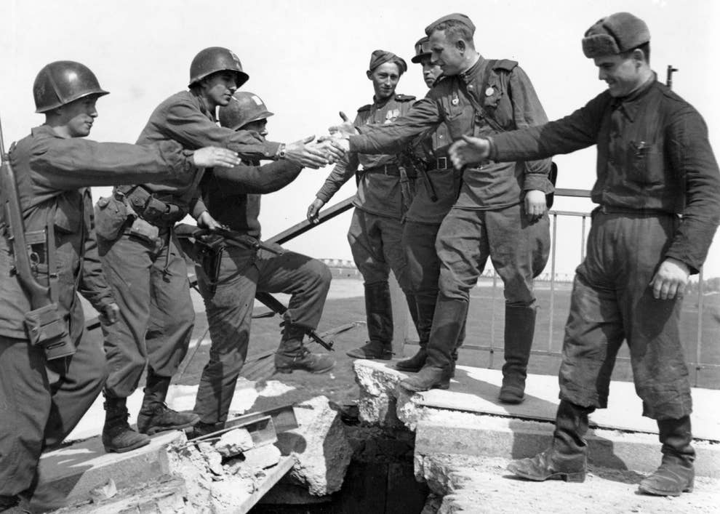
American and Soviet troops pose for a photograph over the collapsed bridge over the Elbe River near Torgau, Germany, 25 April 1945
Module Content
The course will provide an overview of the most important political, social, cultural, and economic developments in Europe in the latter half of the twentieth century and in the twenty-first century. We will analyse Europe’s role in the bipolar world of the Cold War and look at how the continent was divided into a Soviet-dominated ‘Eastern Bloc’ and an American-influenced West for much of the second half of the twentieth century. We will also look at the successes and failures of the ‘European project’ by examining the agenda, politics, and institutions of European integration. The module thus adopts a transnational approach that focuses simultaneously on division and integration, exploring also contacts across the Iron Curtain and parallel developments. The module will consider the legacies of the Cold War in the dissolution of Yugoslavia and Europe’s relationship with Russia (including the conflict in Ukraine), the politics of EU expansion (and, with Brexit, contraction), and the more recent challenges to the liberal order across the continent.

Form of assessment

Two-hour exam at end of semester (100% of total mark)

