National University of Ireland, Maynooth

DEPARTMENT OF HISTORY

FLYERS FOR OPTIONAL MODULES

II ARTS SEMESTER 1 2024-25

PLEASE NOTE

Flyers provide information supplementary to that available in module descriptors, which may be viewed on the university database at www.maynoothuniversity.ie/courses.

Students are expected to consult both flyers and module descriptors, as well as the academic timetable, in advance of registration.

national university of ireland, maynooth
department of history
second arts, 2024-25
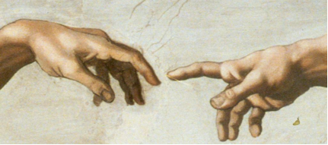
First Semester
Lecturer  DR ALISON FITZGERALD | Module code HY233 | Credits  5 | Lecture hours per week  Two
Module title:

PICTURING THE RENAISSANCE

Module Content:
This elective examines European visual culture during the Renaissance period, with a particular focus on Italy. It explores the production and consumption of art and the role of politics and patronage in shaping the art market. Primary sources, including artists’ biographies, letters, diaries and treatises on art, will be used to consider the ‘rebirth’ of interest in the ancient world, and the artistic developments which lead to the High Renaissance. While focusing primarily on painting, it also considers other media, including sculpture, print and decorative arts. Issues such as the use of art in public and private spaces, artist-patron relationships and the materials and techniques deployed by leading artists such as Michelangelo and Raphael will be investigated.

Learning outcomes:
- An understanding of key artistic developments in Italy during the Renaissance.
- Familiarity with primary sources which facilitate understanding of the context in which art was made, sold, valued and displayed in Renaissance Italy.
- Understanding of patterns of patronage and the commissioning of art for public and private spaces.
- Awareness of the wider context of the art market in Northern Europe and the ways in which ideas about art were communicated.
- Familiarity with the principal materials and artistic processes used to make art in this period.
No previous knowledge of the History of Art is required to take this elective.

Assessment:
Participation: 10%
In-class test: 30%
Essay (3,000 words) 60% Essay deadline: Monday, 6 January 2025
national university of ireland, maynooth
department of history
second arts, 2024-25

First Semester
Lecturer  DR RAUL CARSTOCEA | Module code  HY 281 | Credits  5 | Lecture hours per week  Two

Module title
Modern Europe elective

FASCISM: A TRANSNATIONAL HISTORY
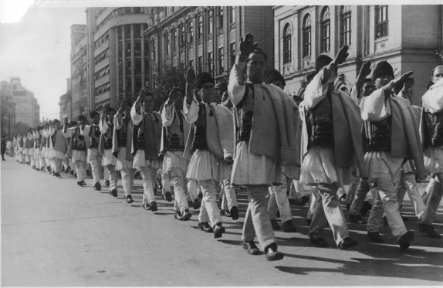
Members of the Romanian fascist movement, the ‘Legion of the Archangel Michael’,
marching dressed in peasant costumes in 1940 Bucharest

Module content
In line with a recent ‘transnational turn’ and an incipient ‘global turn’ in studies of fascism, this module addresses interwar fascism as a European phenomenon, as well as its global entanglements. The module will move beyond the typical case study approach to explore the transnational nature of interwar fascism as an ideology and set of practices. We will adopt instead a thematic approach, covering topics such as the origins of fascism, its relationship to modernity, its attitude to gender, its engagement with colonialism, its genocidal drive, as well as fascism’s mutations after the Second World War and its relationship to the contemporary far and extreme right. Such a thematic approach ensures that, while covering in detail Fascist Italy and Nazi Germany, as well as Imperial Japan, the module will devote equal attention to non-state fascist movements, avoiding their dismissal as ‘minor’ or ‘peripheral’. The transnational approach to an ultra-nationalist ideology allows for a broader understanding of the interplay between the national and the international in politics more generally.

Form of Assessment
Class participation 10%
In-class presentation 30%
3000-word final essay 60% Deadline, Monday, 6 January 2025
national university of ireland, maynooth
department of history
second arts, 2024-25

First Semester
Lecturer  DR DYMPNA MC LOUGHLIN | Module code HY 299 | Credits  5 | Lecture hours per week  Two

Module title
Modern Ireland Social Elective (B)
POVERTY AND WELFARE IN PRE-FAMINE IRELAND, 1800-1845

Overview
The aim of this module is to analyze Irish society, Institutions, family life, disease and death in the prefamine period. Attention will also be paid to the economy, the deteriorating condition of laborers and their families, the ubiquity of public begging by this group, and their political response to their situation in the form of secret societies.
This elective will also engage with the issues emerging from the provision of medical welfare to the destitute in the form of dispensaries, county infirmaries, and a system of county lunatic asylums. It will also discuss the debate over the provision of a system of social welfare to the poor in the form of the poor law Act 1838. Contemporary discussions about charity and poverty will also be included. The issue of public works will also be discussed as work was the key form of welfare favored by the destitute in the prefamine period.
The situation of children on the margins of prefamine society will also be a focus of this module. This will include an analysis of the situation of infants in the foundling hospitals as well as those placed at nurse in the countryside. Young children orphaned as a result of the 1832 cholera epidemic will also be included in the discussion of children and welfare in the pre famine period.
Key outcomes of this module
- Students will have a broad understanding of prefamine Ireland.
- Students will have specific knowledge of all the groups in distress, such as cottiers and labourers and their families.
- Students will understand some of the ways cottiers, labourers and their families reacted to poverty and distress through their involvement in secret societies.
- Students will be aware of the role of the British state in pre famine Ireland and their provision of medical and social welfare to the poor.
- Students will be able to identify the difficulties faced by foundlings and cholera orphans in prefamine Ireland and how these two groups ultimately fared.
Form of assessment
Analysis of primary sources document (2000 words) due mid semester 40%
Essay based on a mixture of primary and secondary sources (3000 words)
due Monday, 6 January 2025 50%
Participation 10%
A range of secondary source documents will be provided and discussed in class. Students then can make their own selection.

national university of ireland, maynooth
department of history
second arts, 2024-25

First Semester
Lecturer  PROFESSOR ROISÍN HIGGINS | Module code HY 2004 | Credits  5 | Lecture hours per week  Two

Module title
A HISTORY OF ULSTER, 1886-1972

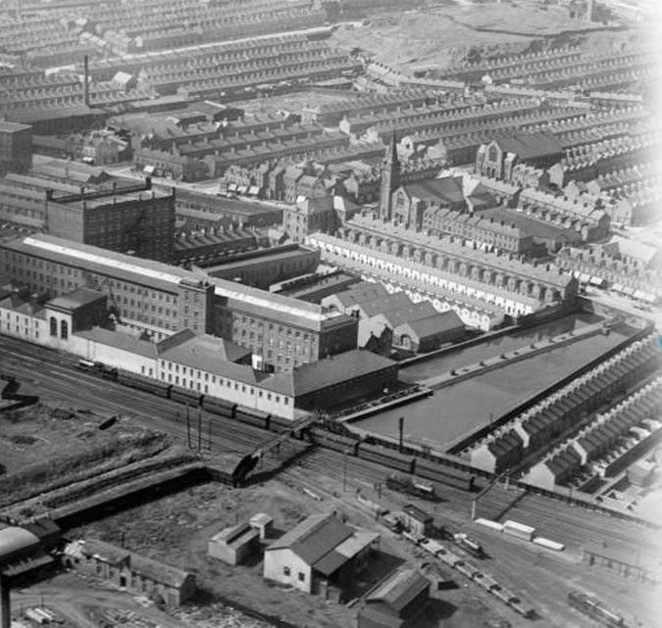
Overview
This module will examine the economic, political and social history of Ulster from the first Home Rule Bill in 1886 to the reinstatement in Northern Ireland of Direct Rule from Westminster in 1972. It will cover areas including revolution, war, partition and the history of the Northern Irish state. Topics will include religion, employment/unemployment, housing, education, families and welfare. There has been a growing interest in the history and politics of partition, and this course will provide a greater understanding of the historical context for the establishment of the Irish border, its impact on the province of Ulster, and on the lives of those who lived along and within bordered land.

Key Objectives
By the end of this module, students will have a critical understanding of the economic, social, and political history of Ulster from 1886 to 1972. They will be able to assess the causes and consequences of partition and reflect upon the causes of division and civil unrest during this period.

Form of assessment
Class participation 10%
Primary source analysis of 1,000 words 20%
Class presentation (December) 20%
Essay of 3,500 words (deadline 6 January 2025) 50%
national university of ireland, maynooth
department of history
second arts, 2024-25
First Semester
Lecturer  PROFESSOR ROISÍN HIGGINS | Module code HY2007 | Credits  5 | Lecture hours per week  Two

Module title
A HISTORY OF SPORT IN MODERN IRELAND

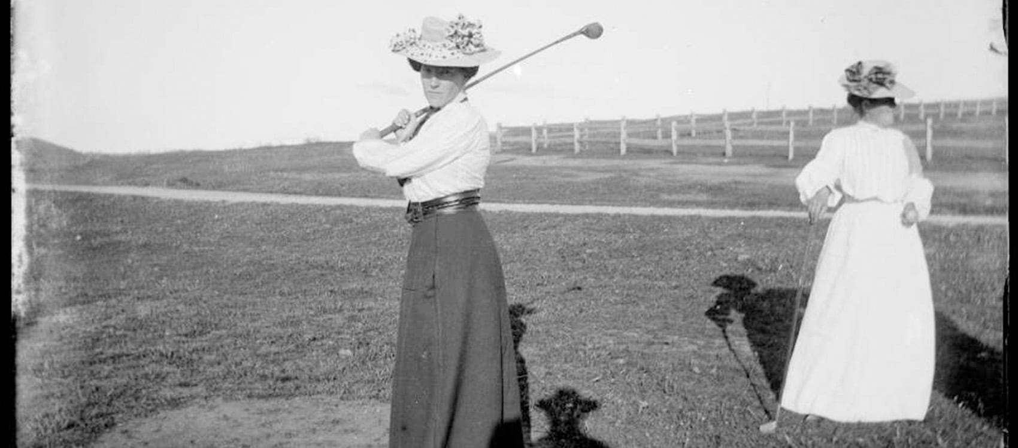

Module content
This module explores the modernisation of sport in Ireland during the nineteenth and twentieth centuries. It examines the social, economic and political forces that led to the codification of sport and how these altered practices of leisure across the island. The module will focus on sports such as boxing, cycling, soccer, golf, horse racing, motor racing and Gaelic Games, and examine them through a prism of imperialism, state formation, partition, gambling, transport infrastructure and identity. Students will consider the ways in which gender, social class and education determined how leisure time was spent and explore the ways in which modernisation and commercialism changed Ireland’s built sporting landscape.
Module Aims
Students will identify and analyse the economic, social and political contexts of changes to sport in Ireland. They will gain an understanding of the significance of the gender, class and education in determining who participates in sporting activities and critically engage with primary material and historiographical debate.

Assessment
Participation 10%
Primary source analysis, 1000 words 20%
In-class presentation 20%
2,500-word essay (deadline for submission Monday, 6 January 2024) 50%
national university of ireland, maynooth
department of history
second arts, 2024-25

First Semester
Lecturer  PROF DEJAN DJOKIĆ | Module code HY 2009 | Credits  5 | Lecture hours per week  Two

Module title
SEARCHING FOR PEACE DURING THE COLD WAR

Overview

Yugoslavia is usually associated with political violence and ethno-religious wars. This module suggests an alternative approach: during its existence (1918-1991), but particularly after 1945, the Yugoslav state offered globally influential models for multi-ethnic co-existence and world peace. The module seeks to explain, in historical and comparative contexts, how this Balkan country, under the leadership of Tito and the Communist Party, re-emerged from the Second World War as a multi-ethnic federation which developed its own brand of socialism; and how it became one of the founders of the Non-Aligned Movement, which offered an alternative to the US-led western and Soviet-led eastern blocs in an aim to prevent a global war.

Form of assessment
Class attendance/participation 10%
In-class assignment 25%
3,000 word essay 65%
Deadline for submission of essay: Monday, 6 January 2025

national university of ireland, maynooth
department of history
second arts, 2024-25

First Semester
Lecturer | Module code SG253 | Credits  5 | Lecture hours per week

Module title
EARLY IRELAND, FROM ST PATRICK TO THE BATTLE OF CLONTARF

Information as per Course Finder, July 2024

Overview
This module offers an introduction to early Irish history, beginning with the life of St Patrick in the fifth century and ending with the death of King Brian Boru at the Battle of Clontarf in 1014. Key themes from the history of early medieval Ireland will be explored, including kingship, identity, social relations, and religion. This module provides a foundational overview of Ireland’s early history and will introduce you to some of the most important primary sources from that period. An era of violence, political struggles and social inequality, it was also a time of great cultural sophistication, when Ireland had a reputation as the ‘island of saints and scholars’. Both aspects of this fascinating period of history will be explored.

24 lecture hours

Form of assessment

50% examination (60 minutes)

50% continuous assessment (one essay)

Please note that SG253 is timetabled by Early Irish (Sean-Ghaeilge) and may clash
with core lectures in other subjects.

For further details contact Early Irish (Sean-Ghaeilge)

national university of ireland, maynooth
department of history
second arts, 2024-25

First Semester
Lecturer | Module code GC217 | Credits  5 | Lecture hours per week

Module title
IMPERIAL ROME, IMPERIAL POWER

Information as per Course Finder, July 2024

Overview
The Roman empire reached its greatest extent in the first and second centuries AD, when at the height of its power it governed territories from Syria to Spain, and from Scotland to the Sahara Desert. This is the age of the Roman Emperors and this module considers the reigns of some of the most famous and infamous of them, from Augustus to Commodus. Imperial Rome, Imperial Power also focuses on the nature of Roman government and society in this period, looking closely both at those who exercised Roman power and authority and those who experienced it or who set out to oppose it. The module, however, seeks to move beyond simplistic models of rulers and ruled, or of ‘imperialism’ and ‘Romanisation’; instead, it makes use of a diverse range of sources from across the empire as a way of identifying the exercise of social, economic, and political power at multiple levels of Roman society and in even the farthest reaches of the Roman world.
18 lecture hours, 3 workshops/tutorials
Assessment
100% Continuous Assessment

Please note that GC217 is timetabled by Ancient Classics and may clash
with core lectures in other subjects.

For further details contact Ancient Classics Department

