How to use our website to make a booking with a voucher code:

- Search our website, www.maynoothcampus.com

- Click the ‘Book Now’ icon in the top right corner to start the booking process.

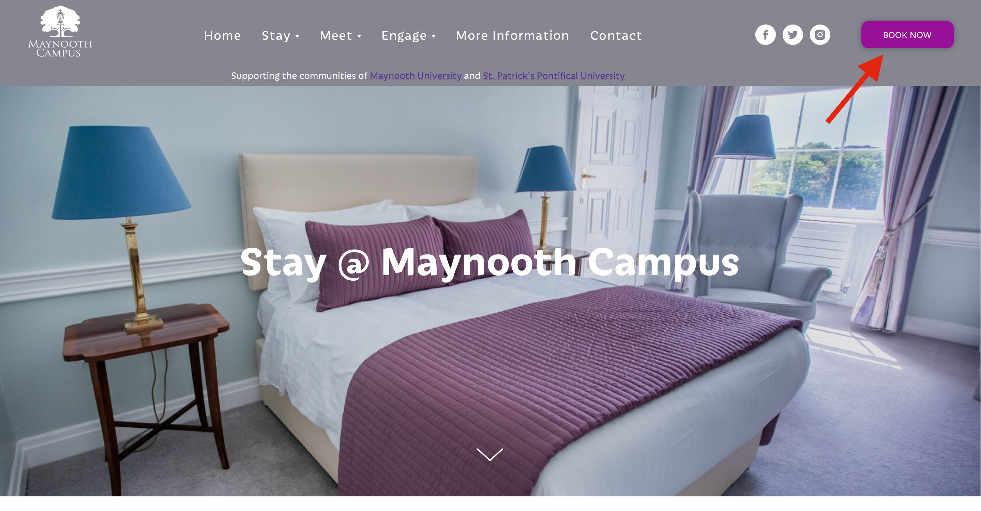

- Choose the dates which you would like to stay.

- Click the ‘Apply Voucher’ box and type in the voucher code given.
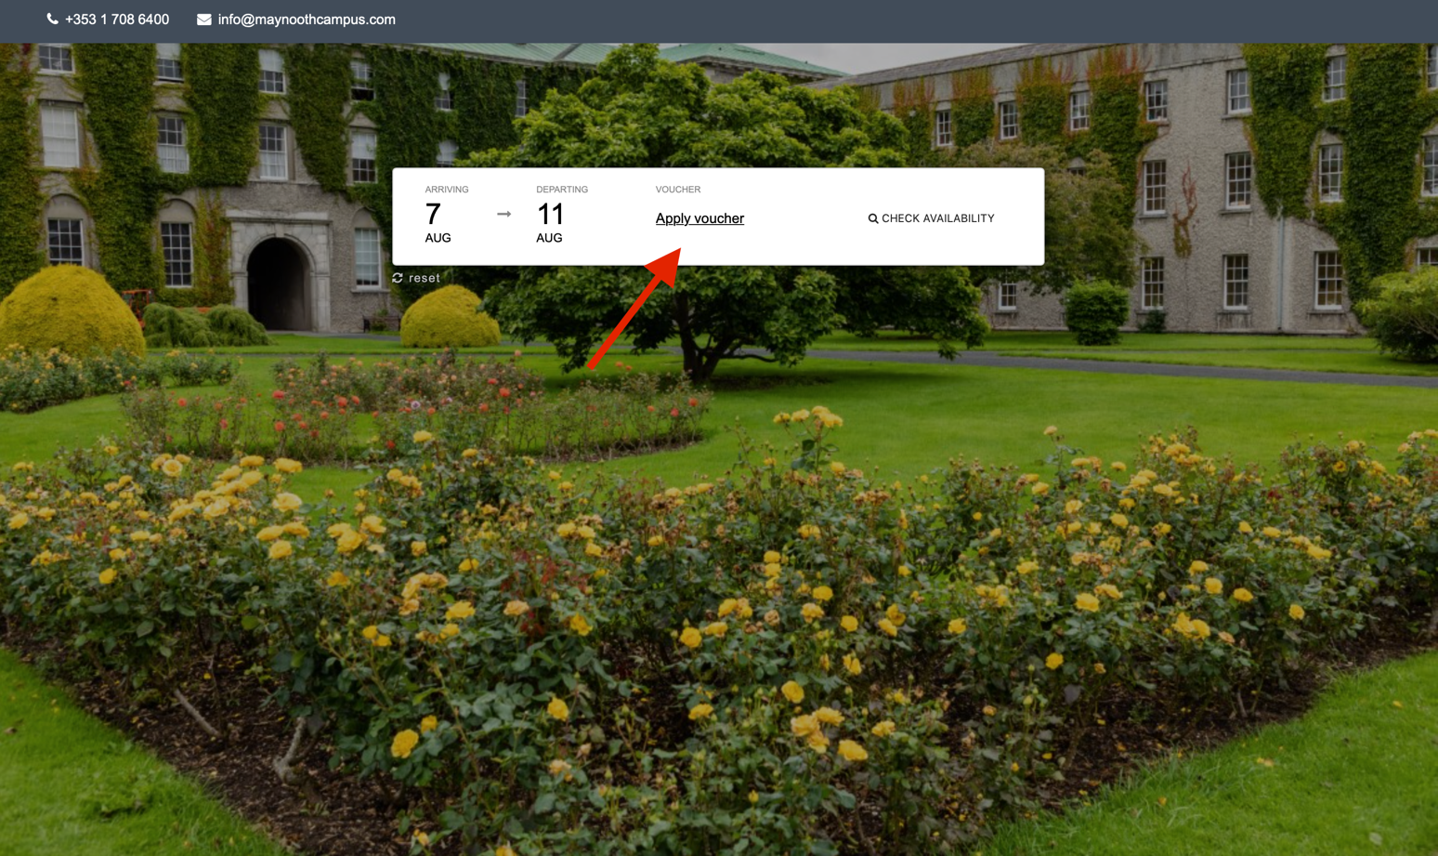

- Once the code has been inputted, select ‘Check Availability’

- Choose the room you would like to book by clicking ‘See Details’ > ‘Room Type’ > ‘Quantity’ > ‘Book Now’ > ‘Next’
- If you want to view our room types and their descriptions, you can do so on our homepage

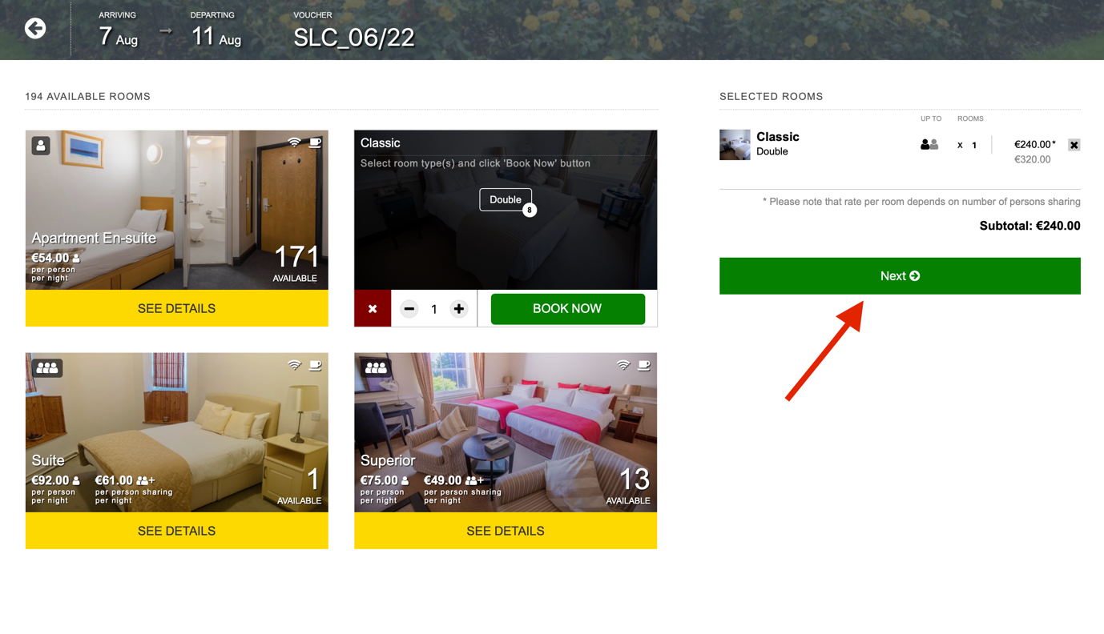
VOUCHER CODE GIVEN

- To complete the booking, fill in the guest(s) details and select ‘Complete Order’ to proceed to the payment page.

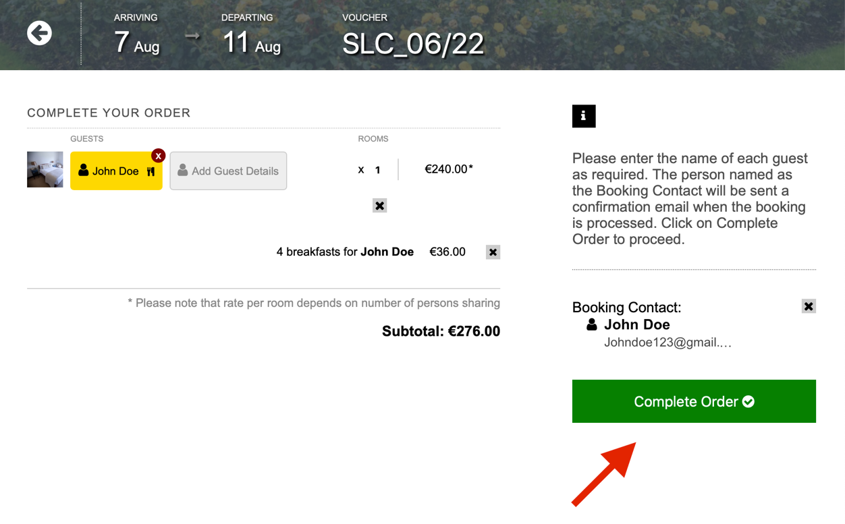

VOUCHER CODE GIVEN

- You will then receive a confirmation email when your booking is complete.

