After the Great War: a New Europe 1918–1923

International outdoor exhibition
National Museum of Ireland
at Collins Barracks, DUBLIN
20 May–17 June 2022

When did the First World War really end? How many new states appeared on the map back then? How long did the military operations continue despite the ending of the war?
Prepared by the European Network Remembrance and Solidarity (ENRS) in cooperation with an international circle of historians, the exhibition marks an attempt to summarise the tumultuous beginnings of the interwar period, with particular emphasis on the history of East-Central Europe.
The commemoration of the Great War in Ireland has a complex history. While Republican communities tended to focus on the 1916 Easter Rising, obscuring the First World War from public memory, the focal point for the cultural memory of the war in Unionist communities was the Battle of the Somme.

The exhibition is an attempt to synthesise the turbulent beginning of the interwar period. Over 200 archive and multimedia materials – pictures, maps and films – together with individual stories of those who lived then present a complex yet coherent picture of New Europe. The main goal of the travelling project is to illustrate the scale of the political changes and their impact on current politics as well as to reveal different national memories.

Prof. Dr Jay Winter (Yale University), a member of the academic advisory board of the exhibition, underlines the following aspect: 'The history of the New Europe that emerged from the ruins of 1914–18 has not yet been told. The upheavals that shaped the world we live in today are impressively documented and illustrated here.'

Although the exhibition refers to well-documented facts, its aim is to present them in an original and refreshing way by highlighting their mutual connections and weaving them into one narrative – logical and coherent, yet taking into account multiple perspectives.

Since 2018, the display has so far been on show in 11 European countries, in such cities as Prague, Sarajevo, Bratislava, Verdun, Berlin, Warsaw, Vienna, Vilnius and Tallinn.

More information about the project, team of experts and the exhibition European tour can be found: www.enrs.eu/afterthegreatwar

The presentation of the exhibition in Dublin is co-funded by the European Union
and carried out in cooperation with the National Museum of Ireland, the Glencree Centre for Peace & Reconciliation and the Embassy of the Republic of Poland in Dublin.

The official opening of the exhibition in Dublin will take place on 20 May at 3 p.m. and will be followed by an open public panel discussion on

‘A New Europe 1918/1923–2022: Memory and Challenges’

with the participation of:

- Prof. Robert Gerwarth, University College Dublin, Ireland;
- Prof. Piotr Juszkiewicz, Adam Mickiewicz University, Poznań, Poland;
- Dr Olena Palko, Birkbeck, University of London, England;
- Dr Jennifer Redmond, Maynooth University, National University of Ireland;
- and will be moderated by Prof. Jay Winter, Yale University, New Haven, USA.

The debate ‘A New Europe 1918/1923–2022: Memory and Challenges' accompanies the opening of the outdoor exhibition ‘After the Great War: a New Europe 1918–1923’. The exhibition presents the complicated emergence of
a new order in Central and Eastern Europe in the first years after 1918. Many of the topics discussed in the exhibition, which took place a century ago, are also very relevant today – especially after the Russian attack on Ukraine. Thus in order to better understand our times, the European Network Remembrance and Solidarity (ENRS) would like to discuss the similarities of the situation and the challenges/threats to the new order in Europe around 1918 and now. The debate will also be devoted to presenting a book that has recently been published: A New Europe, 1918–1923: Instability, Innovation, Recovery, ed. by B. Dziewanowski-Stefańczyk and J. Winter (Routledge, 2022) in the book series established by the ENRS and Routledge. The book offers insights into the political, diplomatic, military, economic and cultural circumstances out of which the New Europe was born. It focuses on three kinds of narratives that relate to conflicts and violence; the recasting of civil society through the creation of new structures and institutions; and to remembrance and the representation of these years in the public sphere.

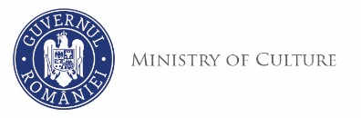
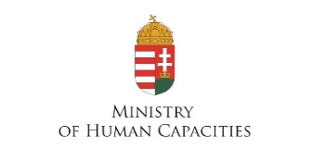
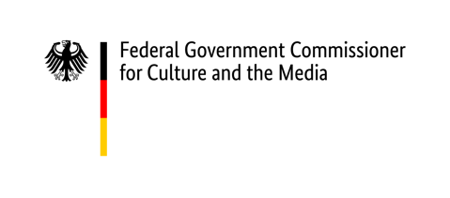
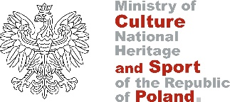
ENRS is funded by:

The European Network Remembrance and Solidarity is an international initiative whose aim is to research, document and enhance the public's knowledge of 20th-century European history and the European cultures of remembrance, with particular emphasis on periods with dictatorships, wars and resistance to political violence. The members of the network are Germany, Hungary, Poland, Romania and Slovakia, with representatives from Albania, Austria, the Czech Republic, Estonia, Georgia, Latvia and Lithuania present in its advisory bodies. www.enrs.eu

